

**INDIVIDUAL ASSIGNMENT**

**TECHNOLOGY PARK MALAYSIA**

**Designing and Developing Applications in the Cloud**

**(CT071-3-3-DDAC)**

**UC3F1610IT(ISS)**

**HAND OUT DATE: 20 APRIL 2017**

**HAND IN DATE: 14 JULY 2017**

**WEIGHTAGE: 100%**

**______________**

INSTRUCTIONS TO CANDIDATES:

1. Submit your assignment at the administrative counter.
2. Students are advised to underpin their answers with the use of references (cited using Harvard Name System of Referencing).
3. Late submission will be awarded zero (0) unless Extenuating Circumstances (EC) be upheld.
4. Cases of plagiarism will be penalized.
5. If you use some code, or ideas for code, which are taken or adapted from another source (book, magazine, internet, discussion forum, etc), then this must be cited and referenced using the Harvard Name convention within your source code. Failure to reference code properly is considered as plagiarism.

# Acknowledgement

The developer appreciates Dr Kalai Anand Ratnam for trying to provide excellent guidance about deploying a system to the cloud and helping us to know more about the services of the integrating Microsoft Azure with other programming platform for the creation of the final working solution that is needed for this assignment. Moreover, this assignment allowed us to acquire better skills in designing, implementing and deploying Web application on Azure with proper use of all the features required.

Table of Contents

Acknowledgement 2

1.0 Introduction 4

1.1 Background of the system 4

1.2 Benefits of using Cloud Services 4

1.3 Objectives 4

1.4 Scopes 5

1.5 Requirement Specifications 5

1.6 Summary of Major Functions 5

2.0 Project Plan 6

2.1 Tasks 6

2.2 Project Schedule (Gantt Chart) 7

3.0 Design 7

3.1 System Design 7

3.2 Cloud Design 8

3.3 Architecture Diagram 9

3.4 Modelling 9

3.4.1 Use Case Diagram 10

3.4.2 Entity Relationship Diagram 10

4.0 Implementation 11

4.1 Publish web application to Azure 11

4.2 Configure online database 12

4.2.1 Create database 12

4.2.2 Create firewall for database 15

4.2.3 Create backup database 16

4.2.4 Create firewall for backup database 16

4.2.5 Geo-replication 16

4.3 Azure Active Directory 18

4.4 Traffic Manager Profile 20

4.4.1 Diagnostics for enabling website logging 22

4.5 Performance Testing 24

4.5.1 Primary database performance 27

5.0 Testing 28

5.1 Register Page 28

5.2 Login Page 28

5.3 Main Page 29

6.0 Critical Evaluation 30

7.0 Conclusion 30

8.0 Personal Reflection 30

9.0 Appendix 31

# 1.0 Introduction

## 1.1 Background of the system

Maersk Line is a container shipping company that is situated in Malaysia which is in the region of South East Asia. It manages cargo to transport goods to the world. It also manages its own data center. The transportation is the core business of the company while information technology is the enabler for its business. Since the cost of managing on premise is increasing, the company decided to migrate its services to the cloud in order to sustain its business.

## 1.2 Benefits of using Cloud Services

The benefits for the migration of services from on premise to cloud service are as follows:-

* The capital expenditure is low compare to on premise, while operating expenditure is lower as well compare to on premise due to the fact that cloud service is expanded according to pay per user.
* Availability is very high as the cloud service provider is not easily interrupted.
* Maintaining and monitoring the services are much easier and effective.
* Cost effective to scale up or scale out depending on demands.

## 1.3 Objectives

The objectives of the system is stated below:

* To develop a single web application in order to reach the business needs on Microsoft Azure Platform.
* The web application should be able to provide any upgrades or maintenance while multiple users are using it.
* The web application must be easy to monitor for errors.
* The web application should always be available and also it should be unaffected by the activities of other users.
* The web application should be scalable in order to deliver a better performance on azure portal.

## 1.4 Scopes

The scope of the assignment are as follows:-

* The programmer has little to no knowledge on developing a web application, this means that most of the functionalities are not present and may not work, while there may be a lot of bugs in the application.
* The cloud service is implemented in the region of South East Asia.
* There consists of one primary database and one backup database only.

## 1.5 Requirement Specifications

The requirement specifications of the system are shown below:

* SQL Server Express Edition
* Microsoft Visual Studio 2017 Professional Edition
* Microsoft Azure Account with subscription of Visual Studio Dev Essentials that has Developer Program Benefit

## 1.6 Summary of Major Functions

The major functions of the system are shown below:

* The user can login and register
* The user can view, add, edit, and delete the shipment information

# 2.0 Project Plan

The Shipment Management System for Maersk Line Company is a system that requires time management in order to develop the system. The tasks are identified before creating the Gantt Chart.

## 2.1 Tasks

The tasks are listed below:

* Introduction
* Gathering of the important details for Shipment Management System
* UML diagram
* Use Case diagram
* Entity Relationship Diagram
* Planning of Web Structure
* List of Features and Functions
* Implementation
* Client site
* Admin site
* Azure integration
* Testing
* Conclusion

## 2.2 Project Schedule (Gantt Chart)

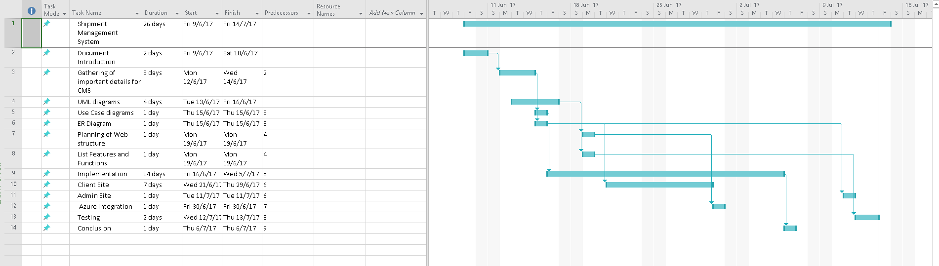

# 3.0 Design

## 3.1 System Design

The website for Shipment Management System is developed using ASP.NET Web Application MVC (.NET Framework) C# with entity framework 4.5.2. Diagram below shows the structure of the project which was created in visual studio for the design pattern of the system.

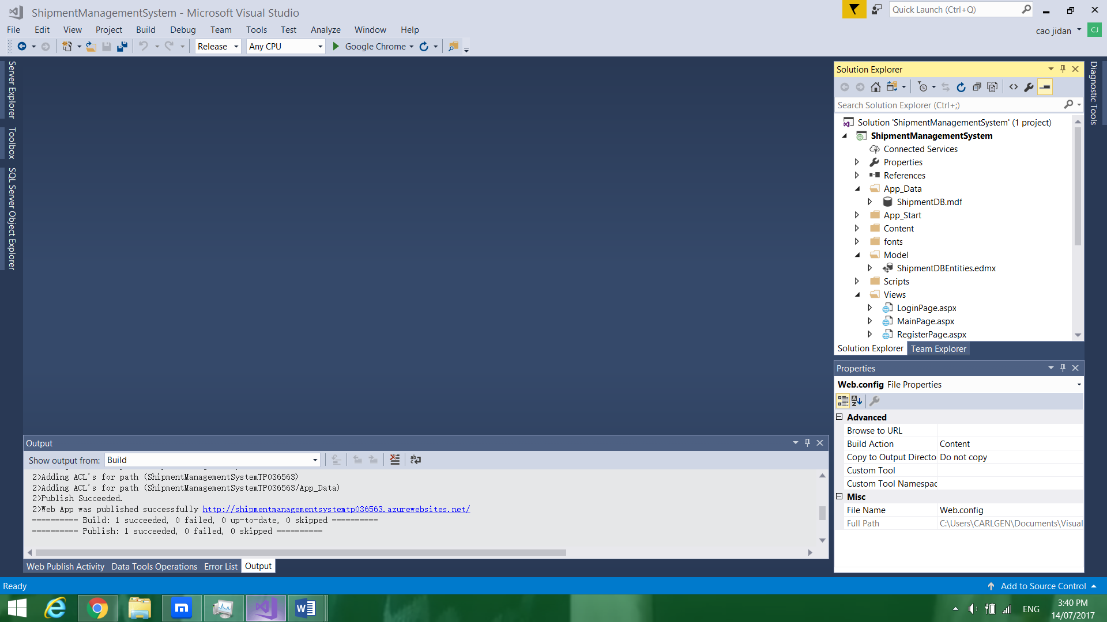

-App_Data

Stores the metadata of local database which is called “ShipmentDB.mdf”. After opened, the database is shown in Data Connection within Server Explorer. The online database is shown in Server Explorer and SQL Server Object Explorer.

-Model

The entity model of the database is stored here and it is called “ShipmentDBEntities.edmx”.

-Views

The views and controller of the system are stored here and there are LoginPage, MainPage, and RegisterPage. The ASPX format are the views while the CS format are the controller.

## 3.2 Cloud Design

Github allows the developer to upload the original source code to the internet which helps the developer update the source code more easily. Microsoft Azure provides a variety of services. The services that has been implemented in the system are publishing the system to the cloud, connecting web application with online database, Azure Active Directory, Traffic Manager Profile, Performance Testing. With Azure Active Directory, the developer can managed the user role for each user and assign the suitable permission for the user which can greatly enhance the security of the system. Traffic Manager Profile can ensures that all the users have reliable and better performance while connecting to the system. Performance Testing helps the developer to analyze whether the system requires any scale up or scale out for the system as well as to ensure that there is better performance and reliability for the system.

## 3.3 Architecture Diagram

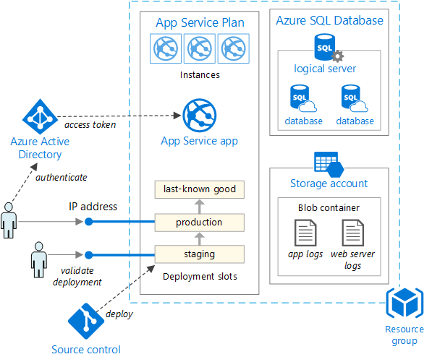

The above diagram is implemented to the system

## 3.4 Modelling

The diagram below shows the model of the system.

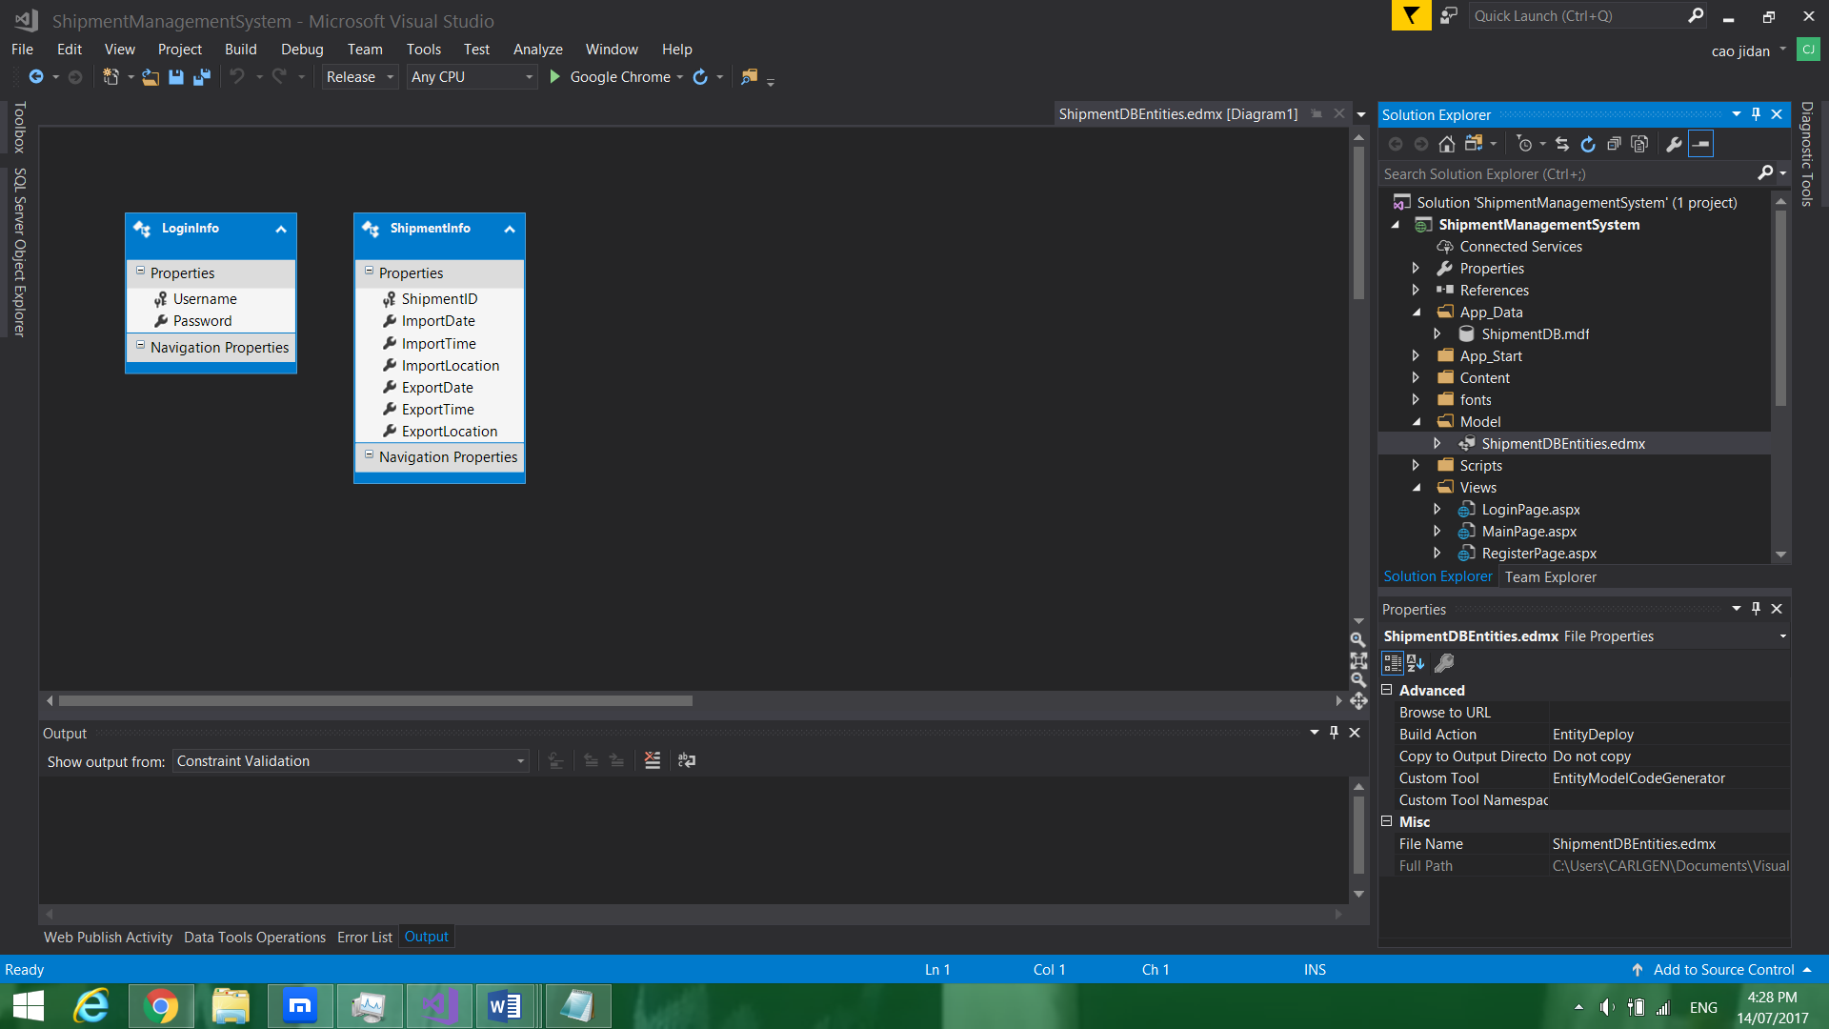

### 3.4.1 Use Case Diagram

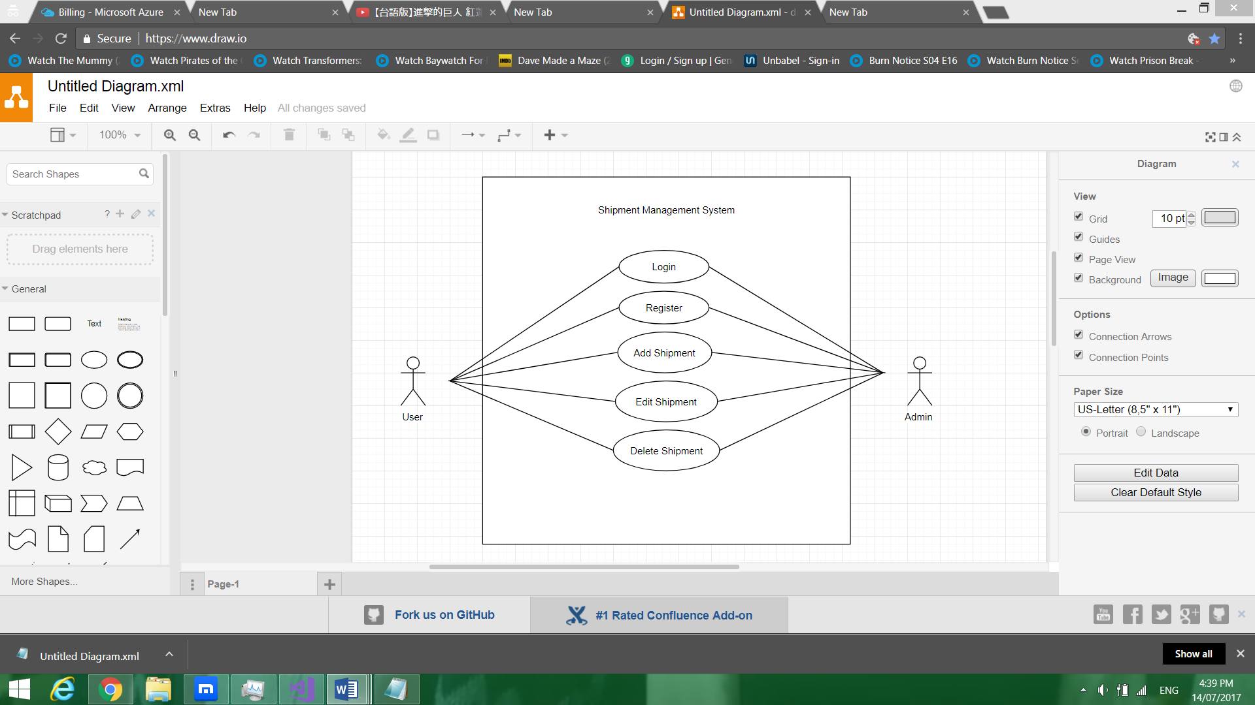

### 3.4.2 Entity Relationship Diagram



# 4.0 Implementation

## 4.1 Publish web application to Azure

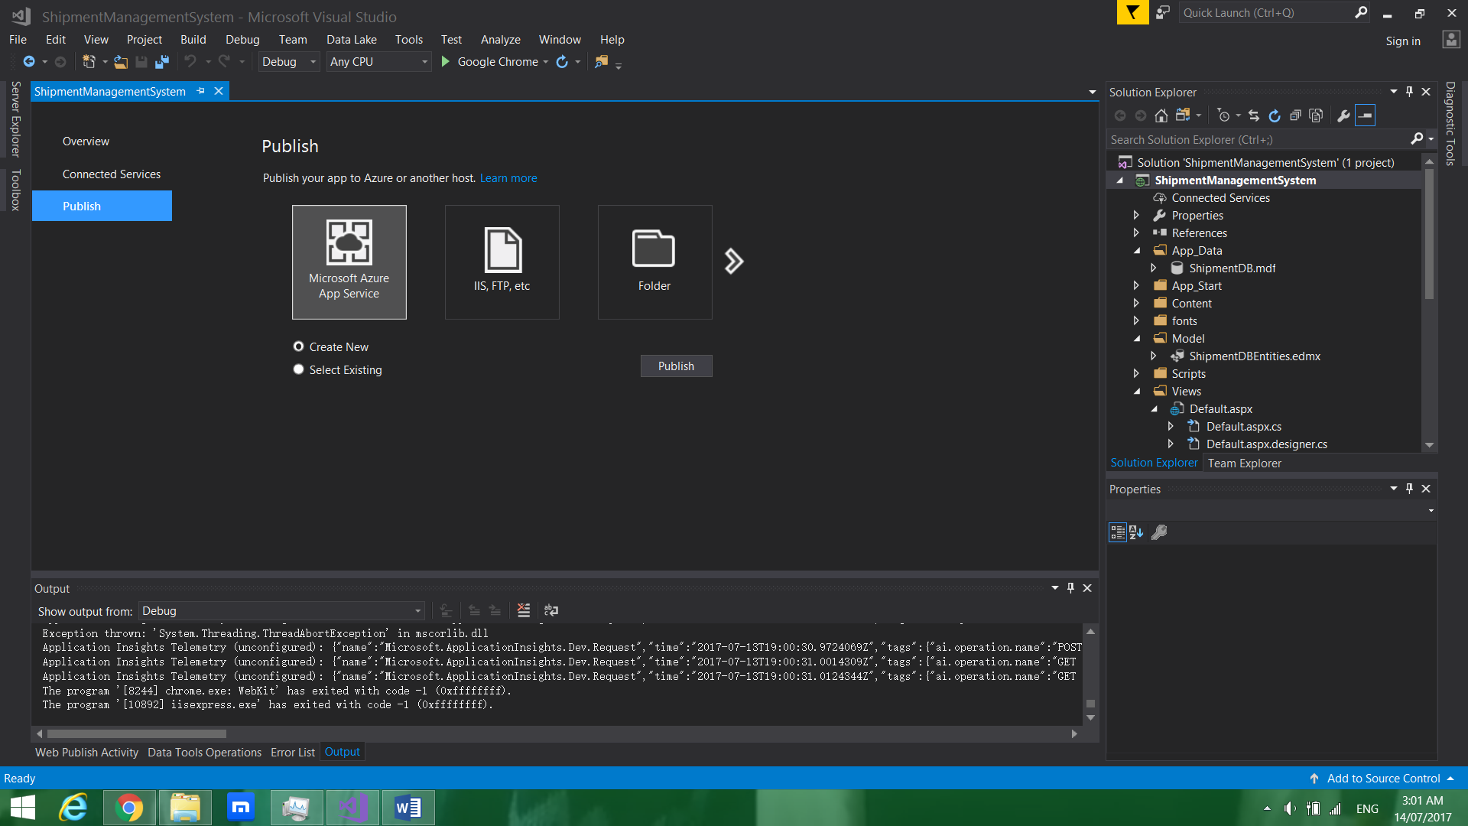

The diagram above shows for creating new web application and upload the system.

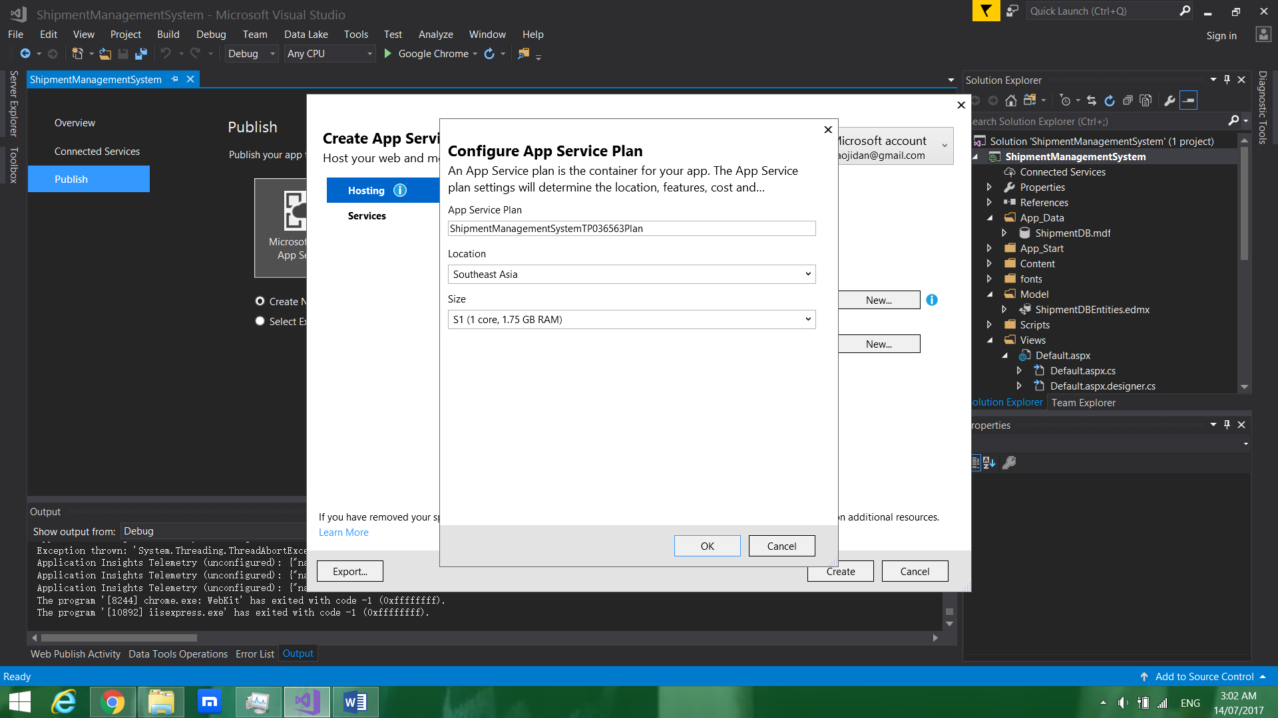

The diagram above shows for configuring the app service plan.

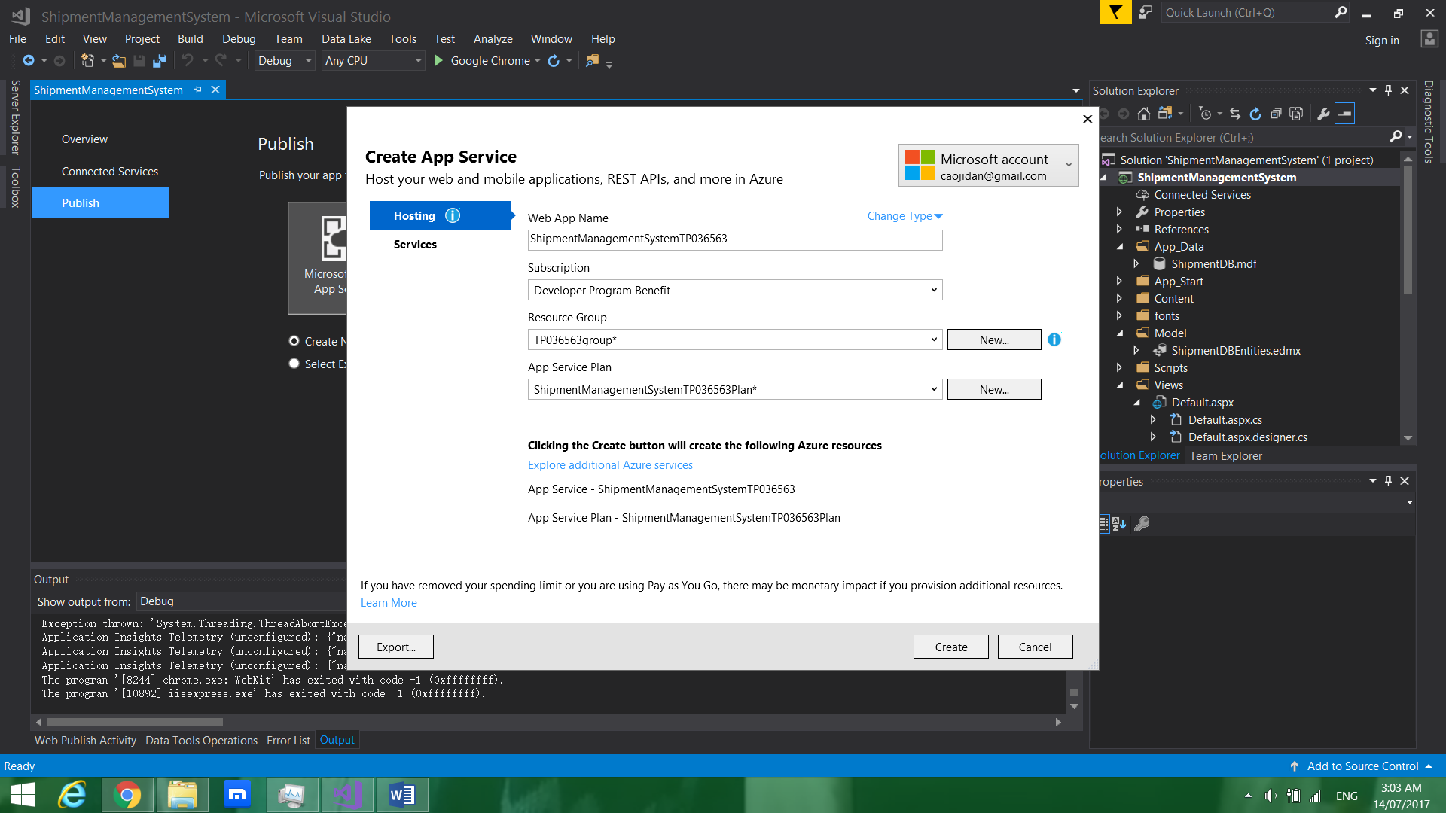

The diagram above shows for creating the app service.

## 4.2 Configure online database

### 4.2.1 Create database

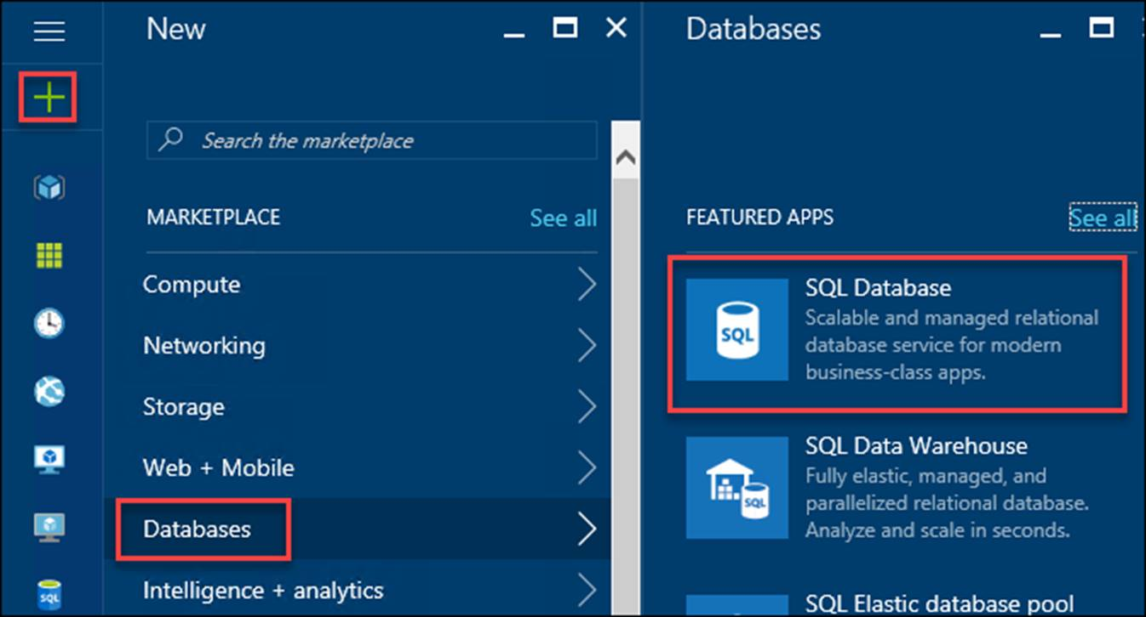

After creating the SQL server, the diagram above shows for creating SQL database

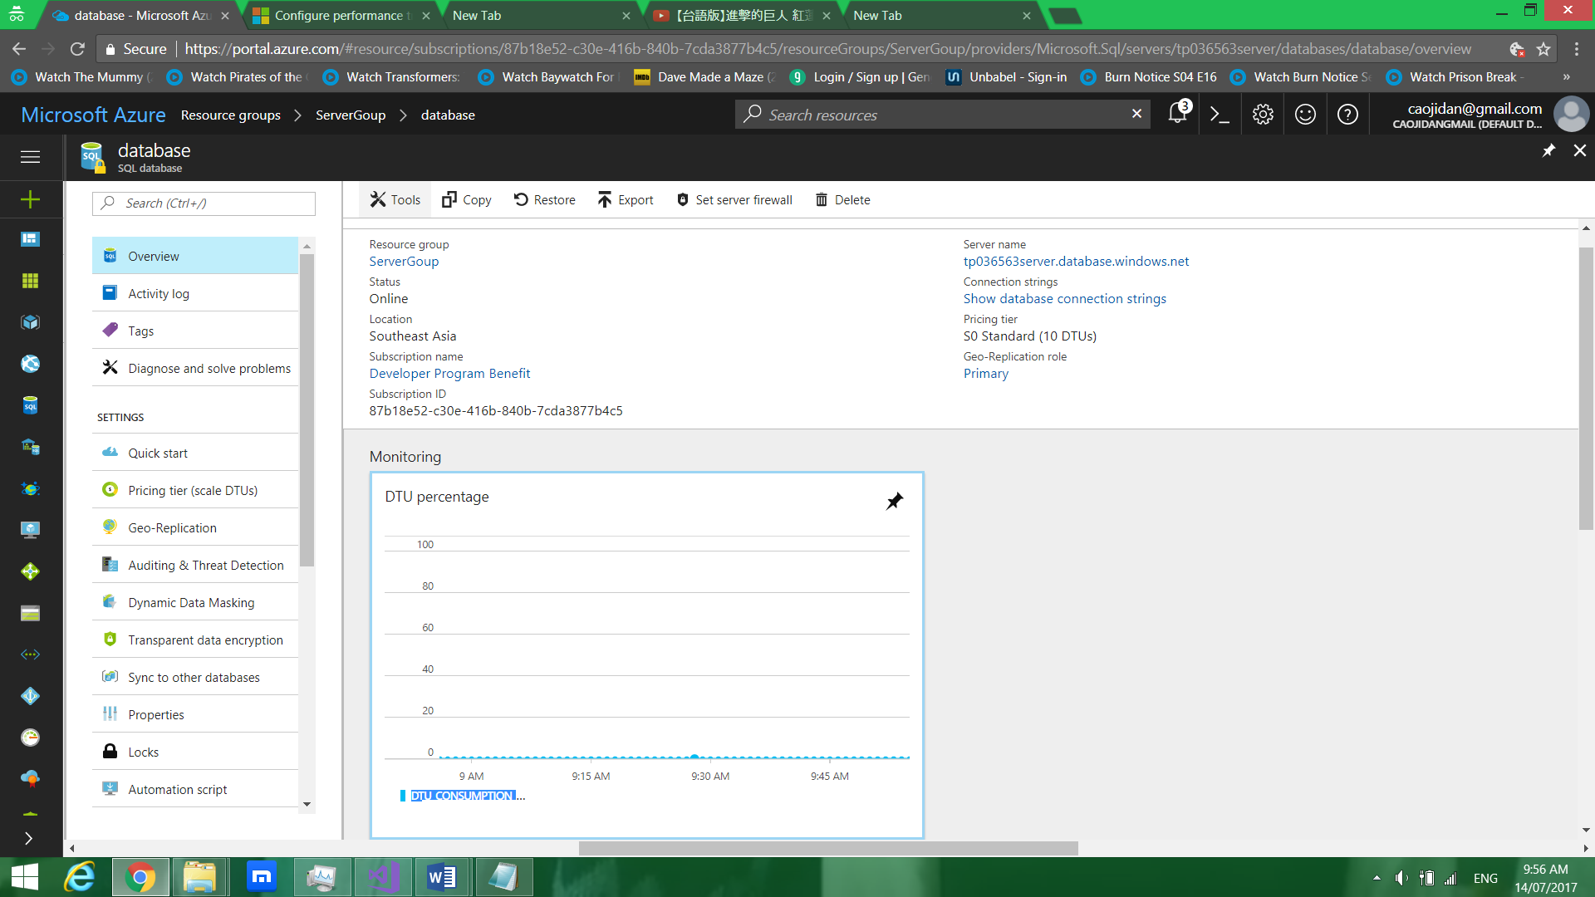

The diagram above shows for linking the online database with visual studio 2017.

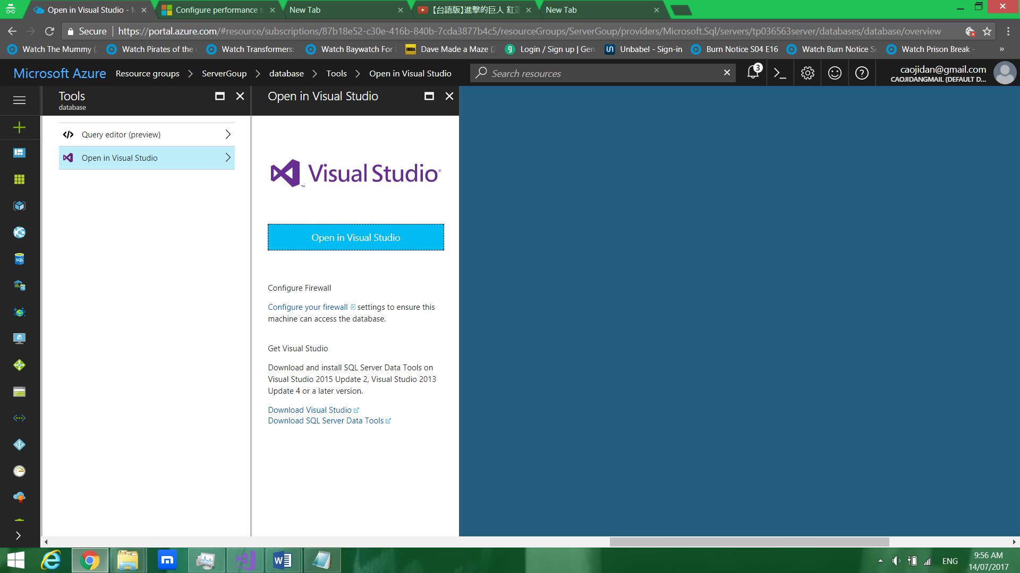

The diagram above shows for linking the online database with visual studio 2017.

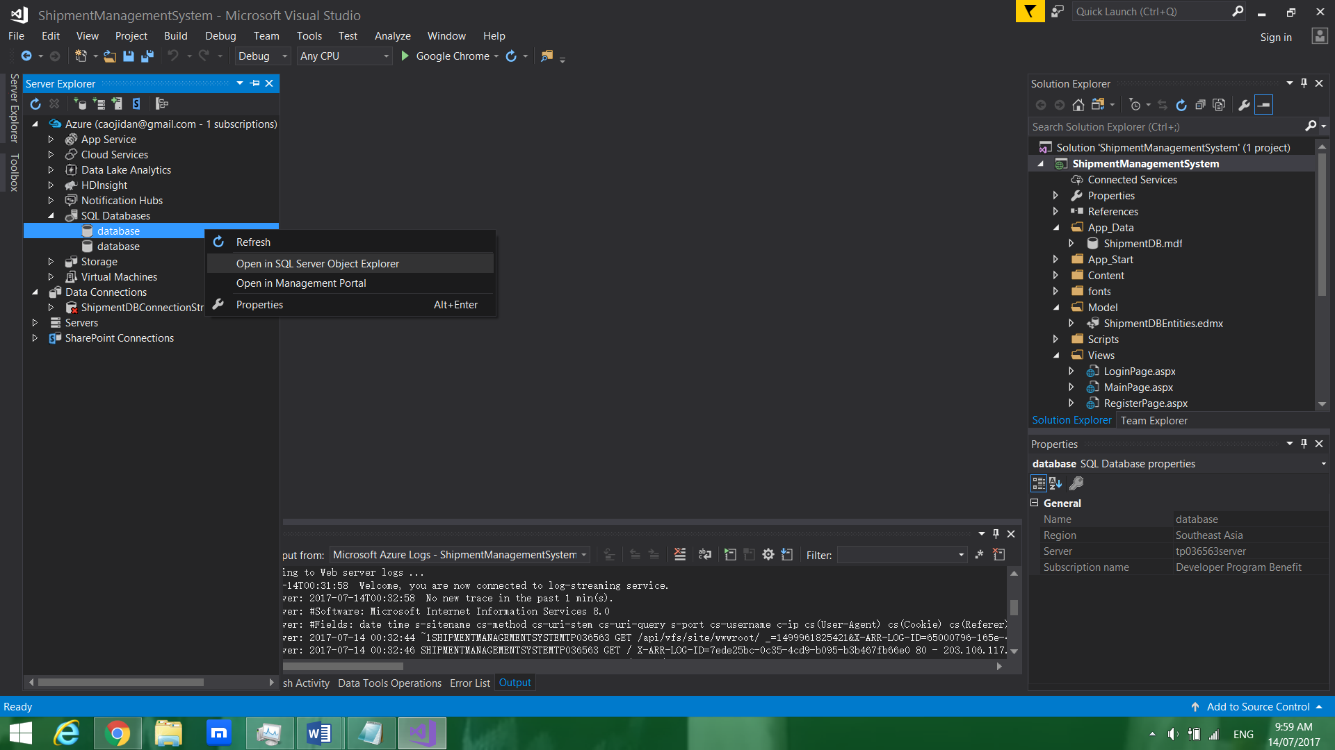

The diagram above shows for opening database in SQL Server Object Explorer.

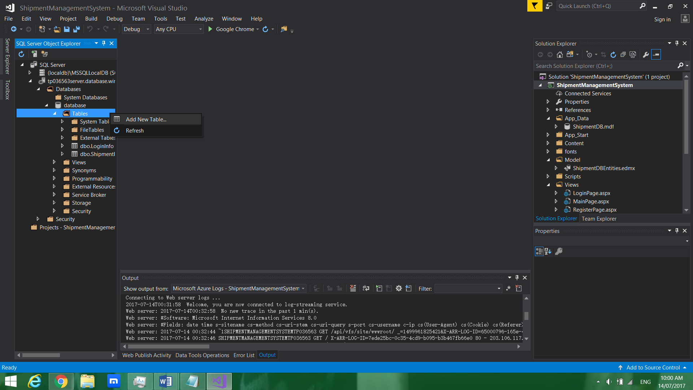

The diagram above shows for creating new table.

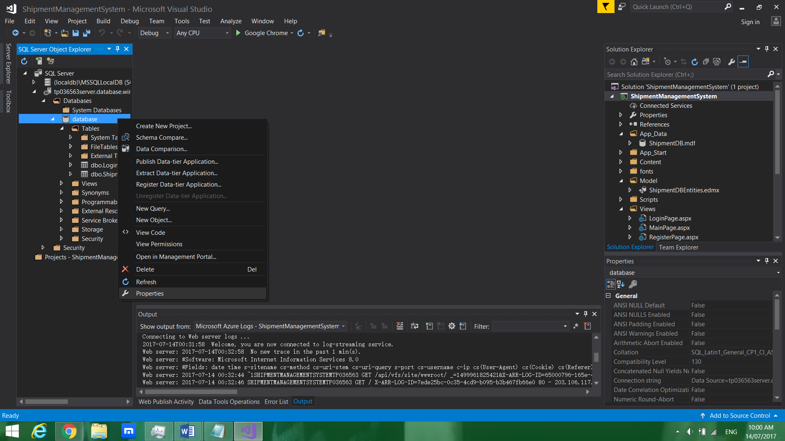

The diagram above shows for opening the properties of the database.

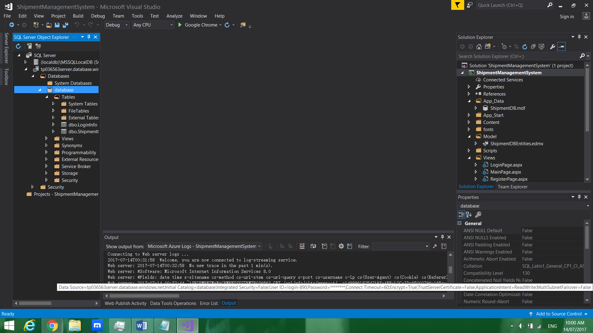

The diagram above shows for shows the connection string that needs to be copied.

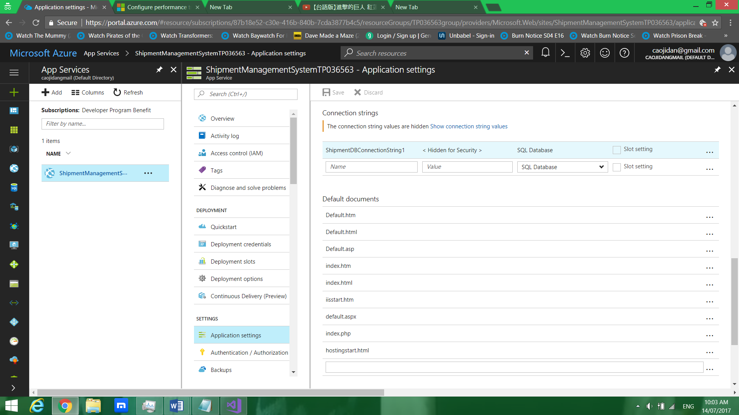

The diagram above shows for changing the connection string that is copied previously.

### 4.2.2 Create firewall for database

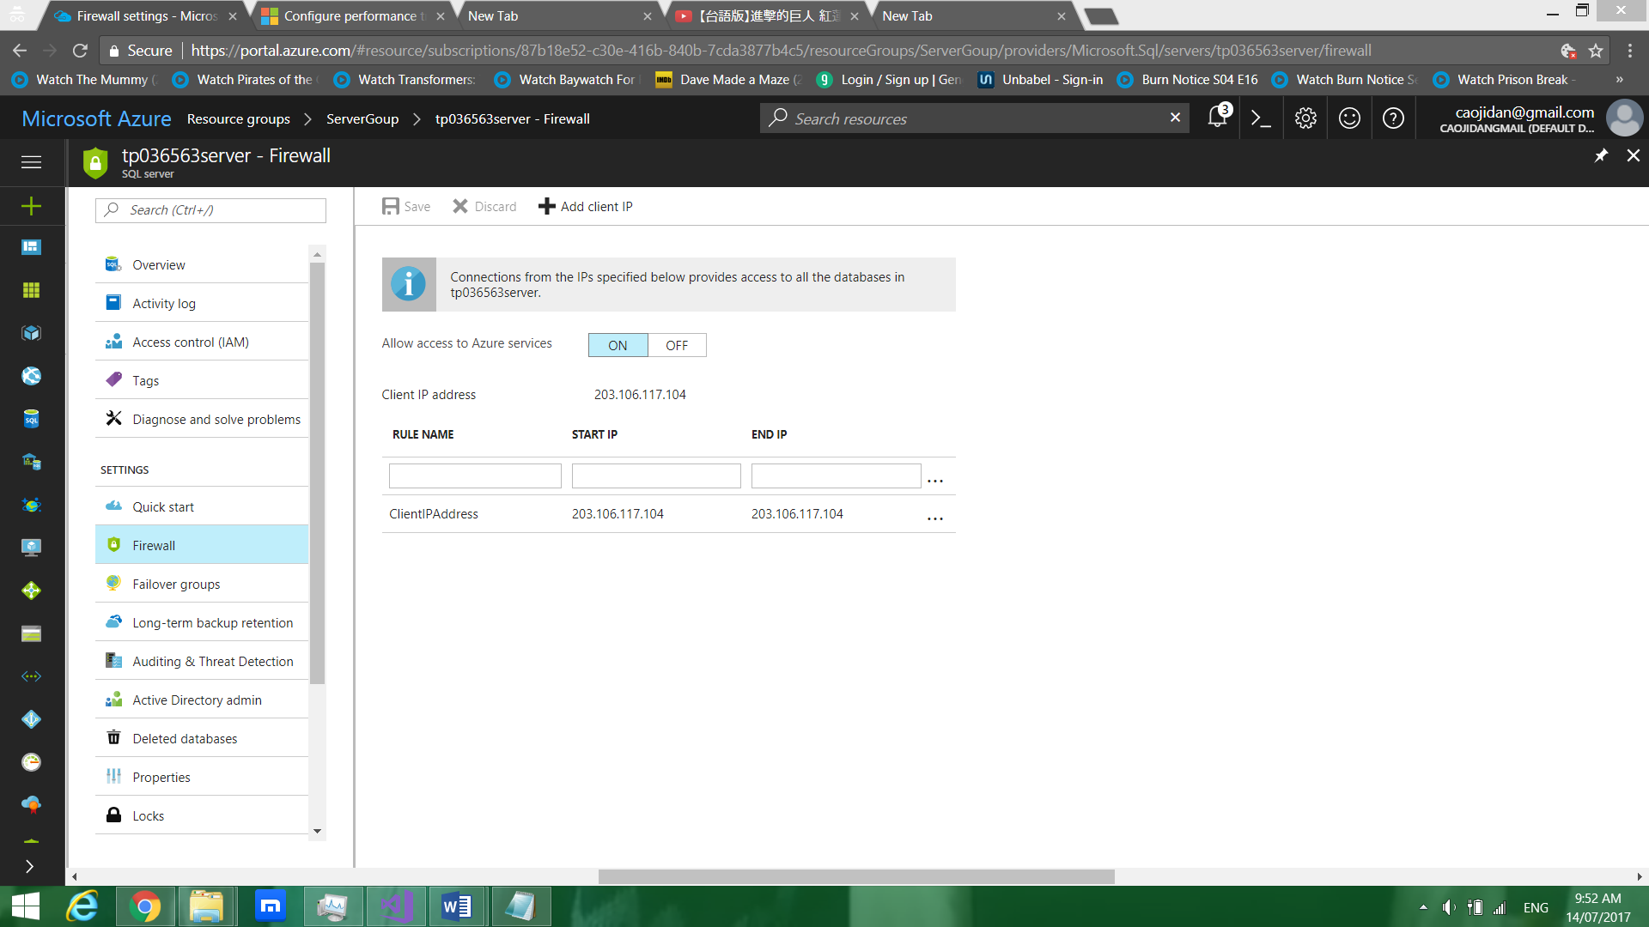

The diagram above shows for managing the range of the public IP address that the user can access the website from.

### 4.2.3 Create backup database

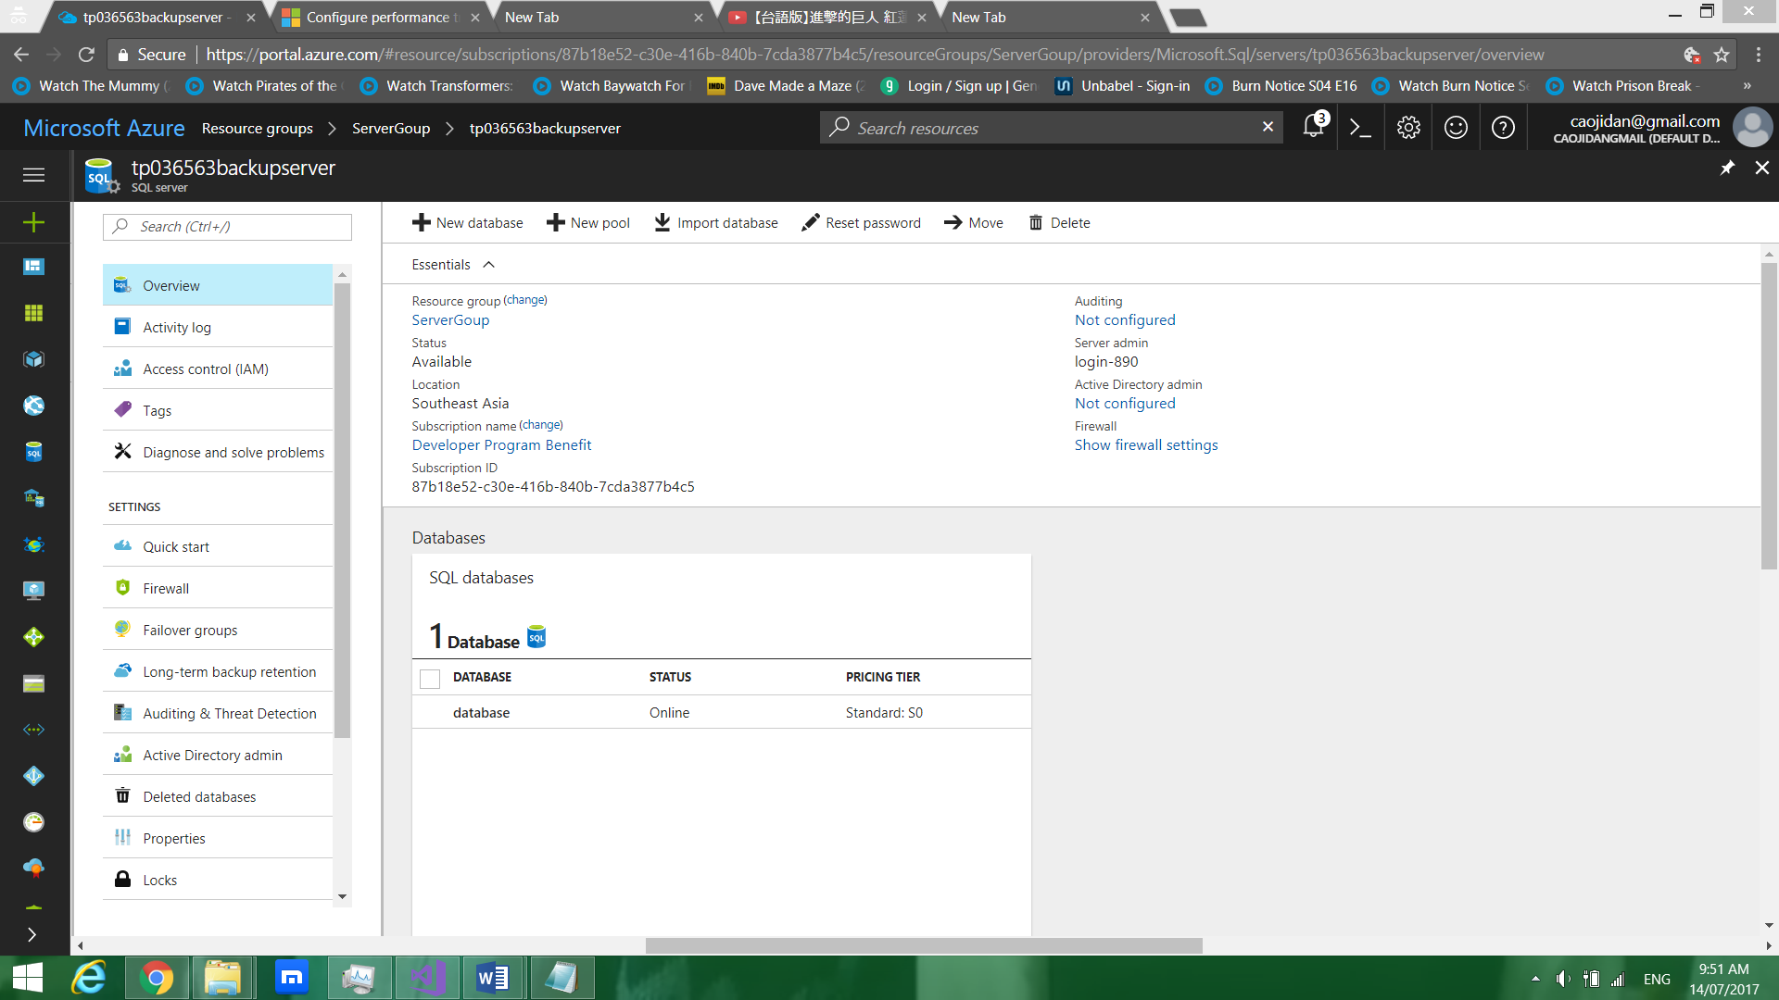

The diagram above shows for creating the backup database.

### 4.2.4 Create firewall for backup database

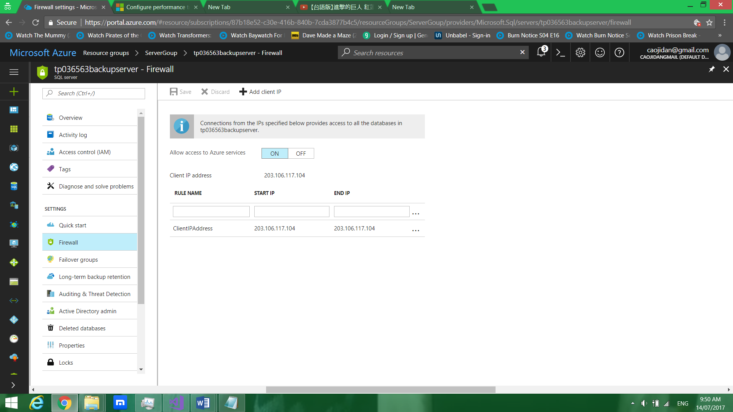

The diagram above shows for configuring the firewall.

## 4.2.5 Geo-replication

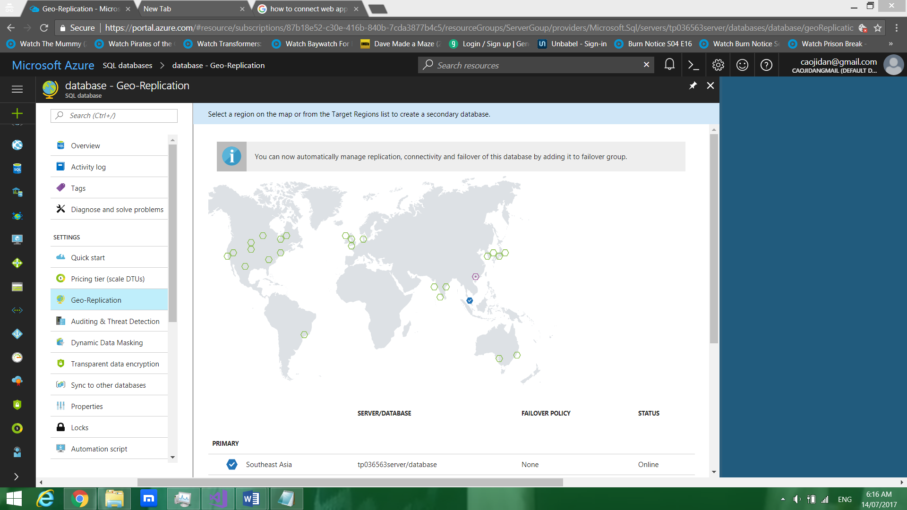

The diagram above shows for creating geo-replication for primary database.

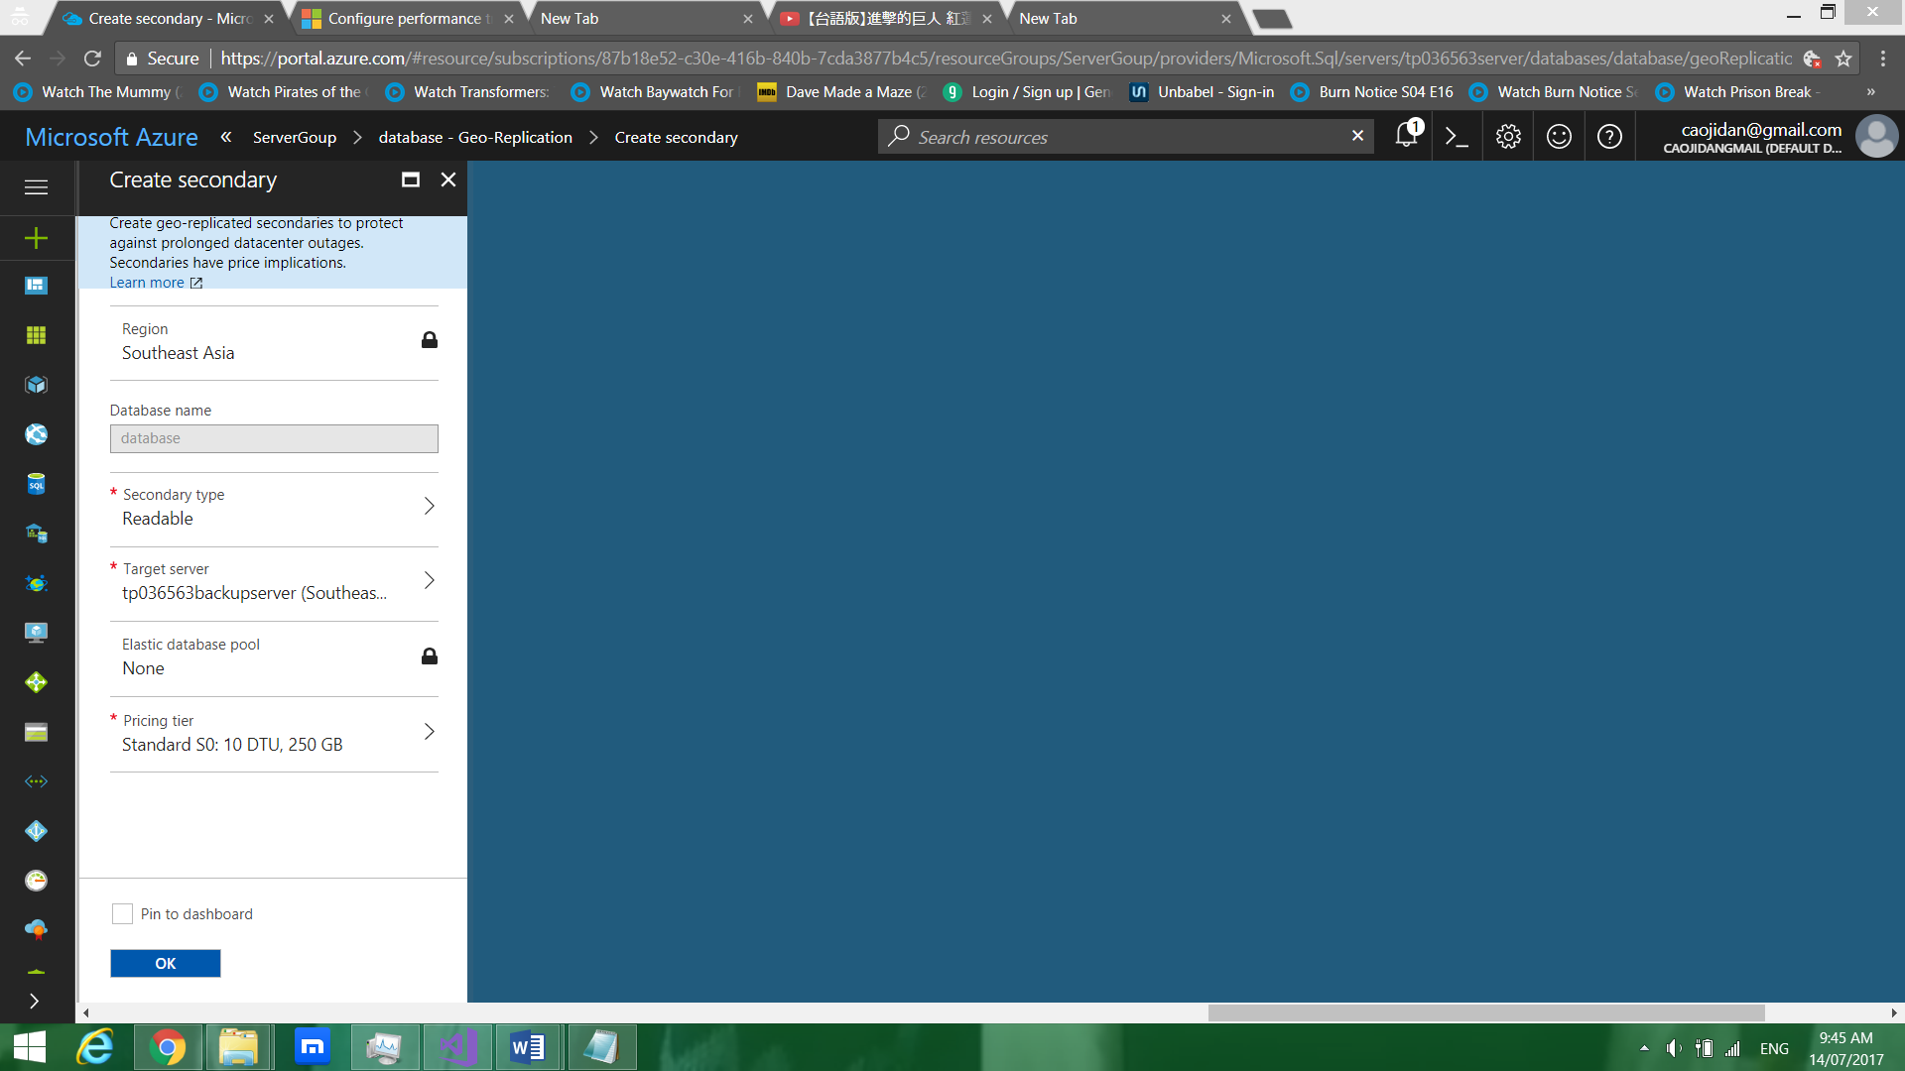

The diagram above shows for creating geo-replication for primary database.

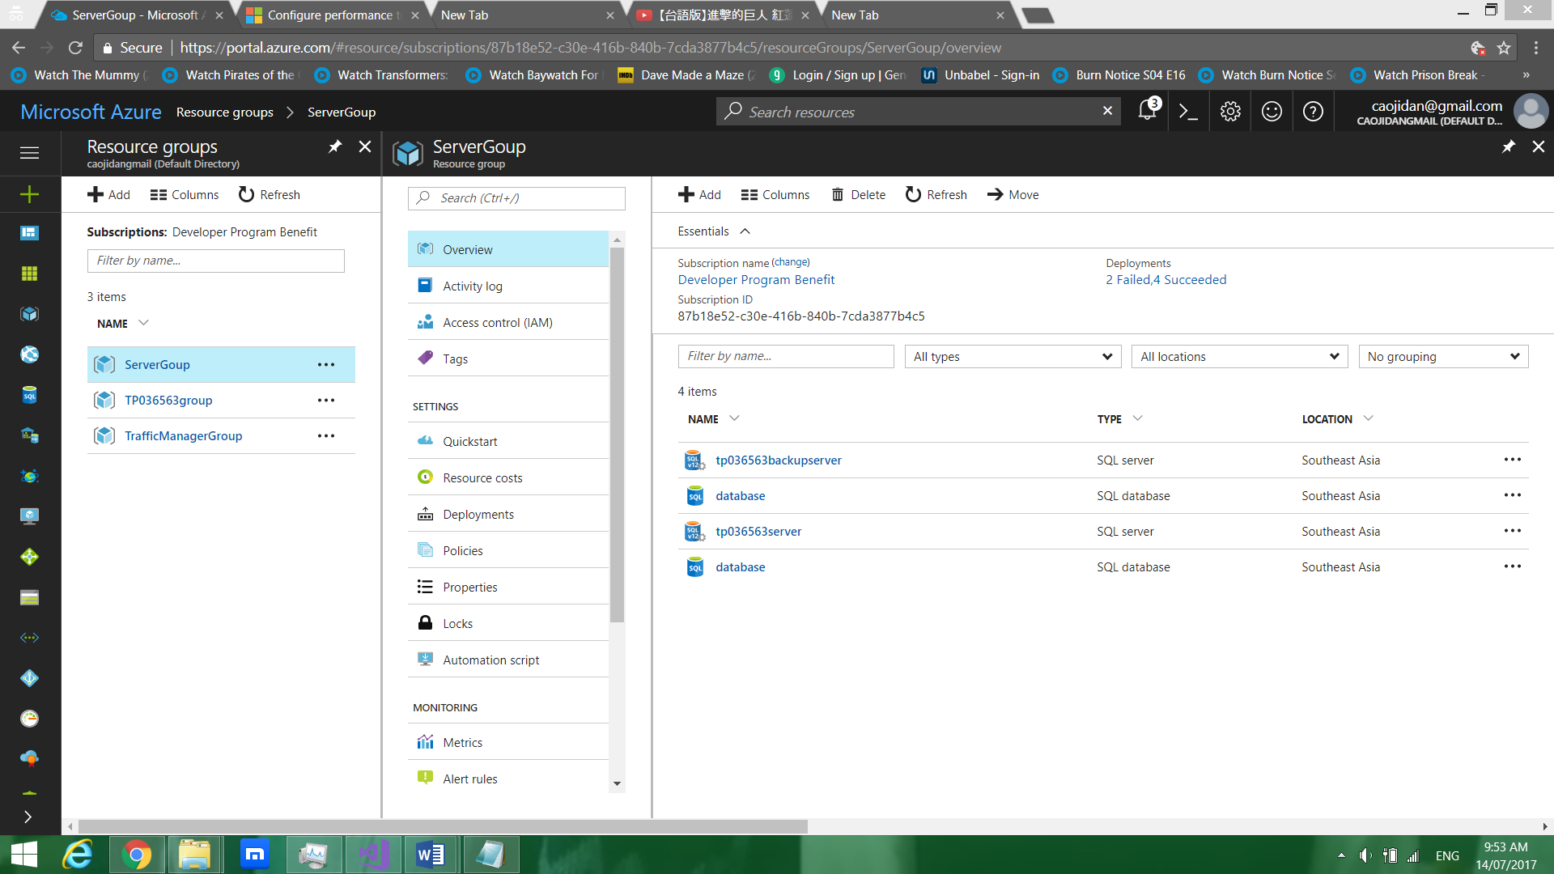

The diagram above shows the end result of the two database.

## 4.3 Azure Active Directory

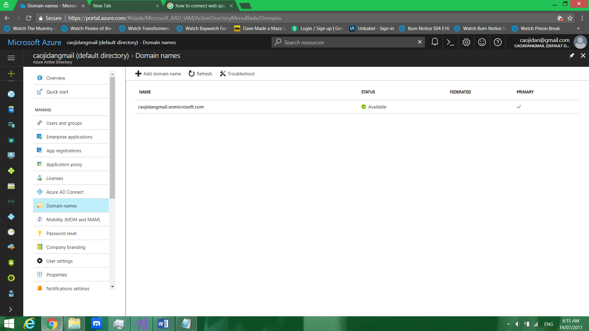

The diagram above shows the domain name that needs to be copied.

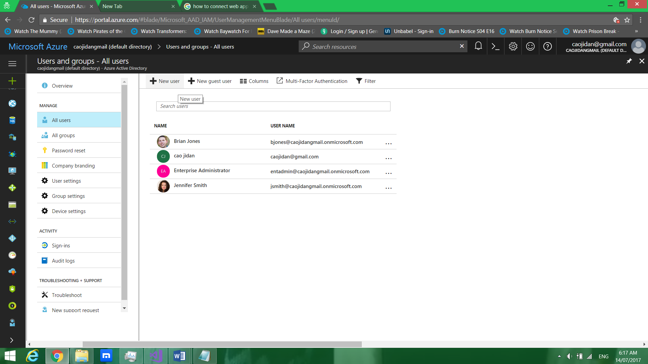

The diagram above shows for creating the new user.

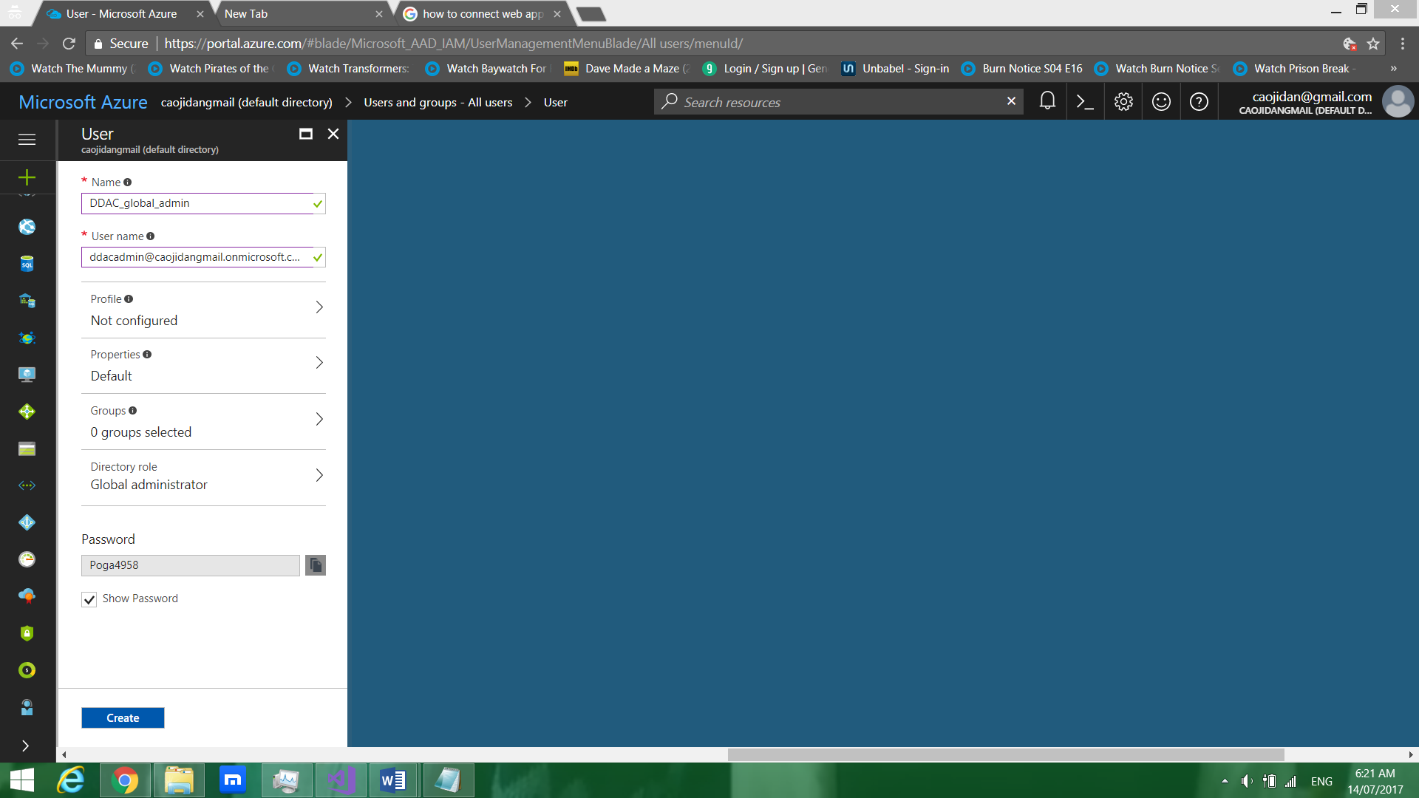

The diagram above shows for configuring the new user.

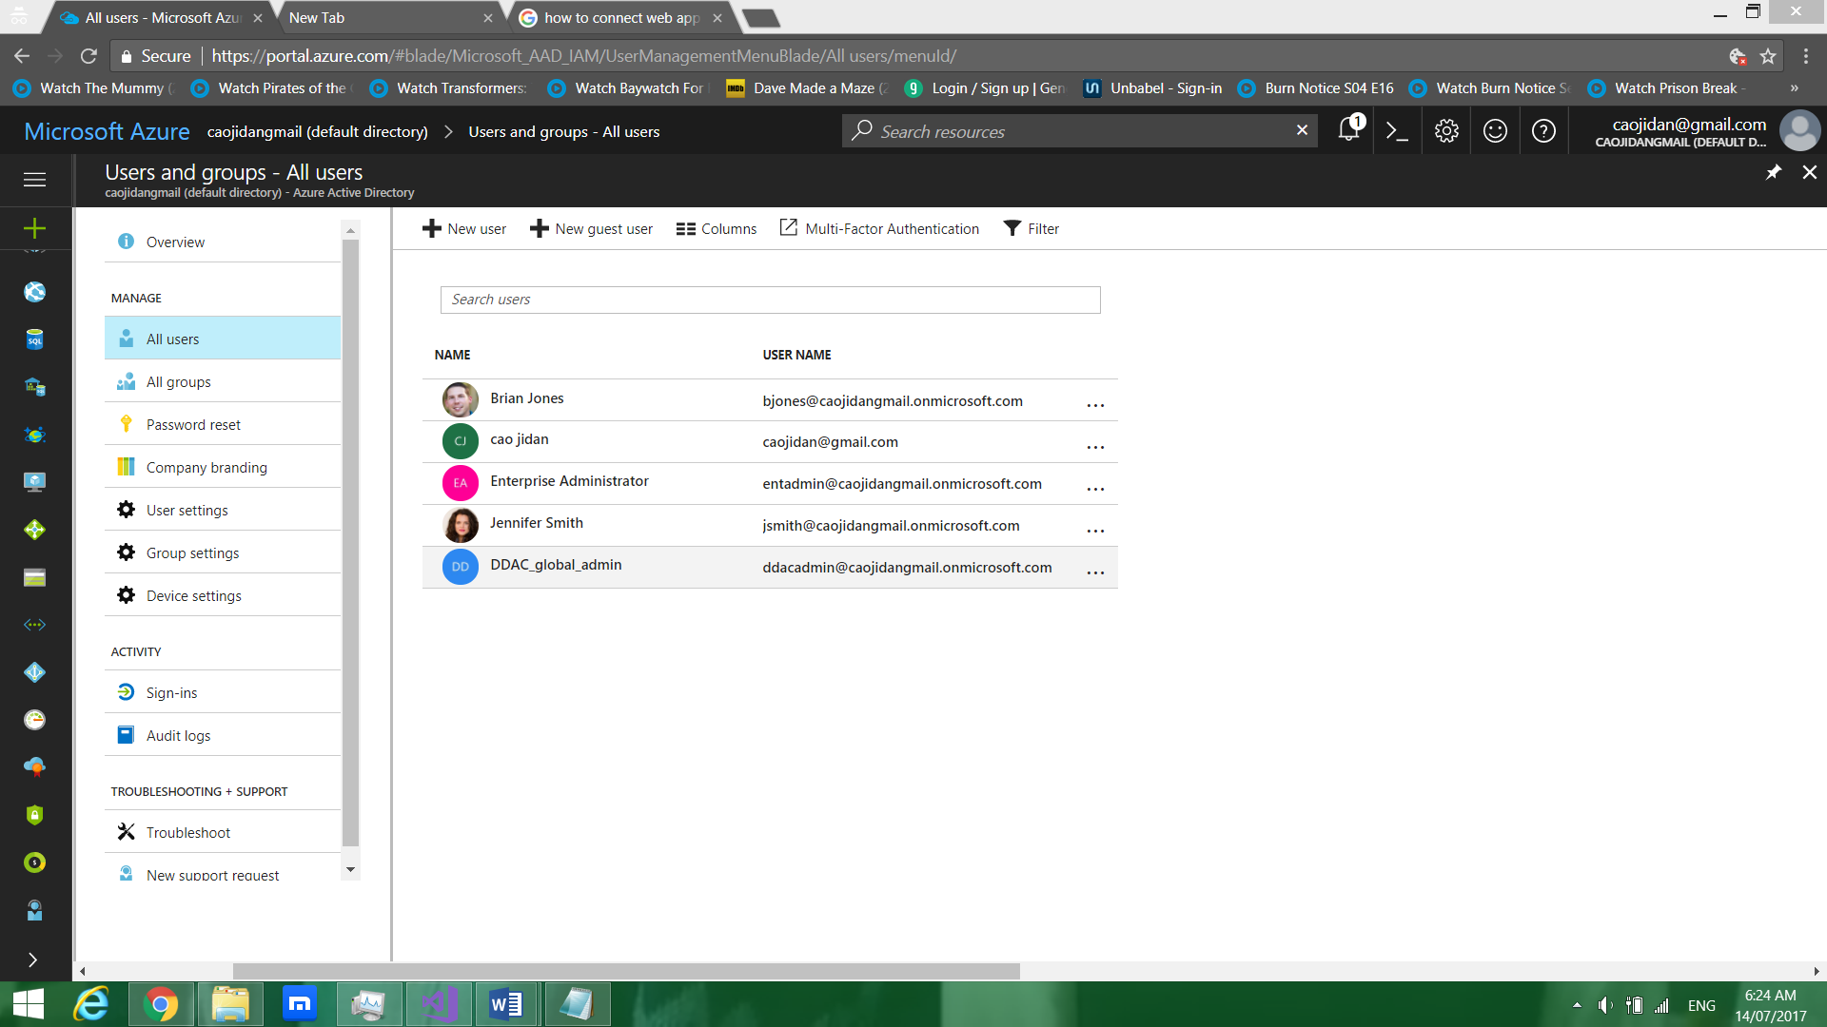

The diagram above shows the end result of the creating new user for Azure Active Directory.

## 4.4 Traffic Manager Profile

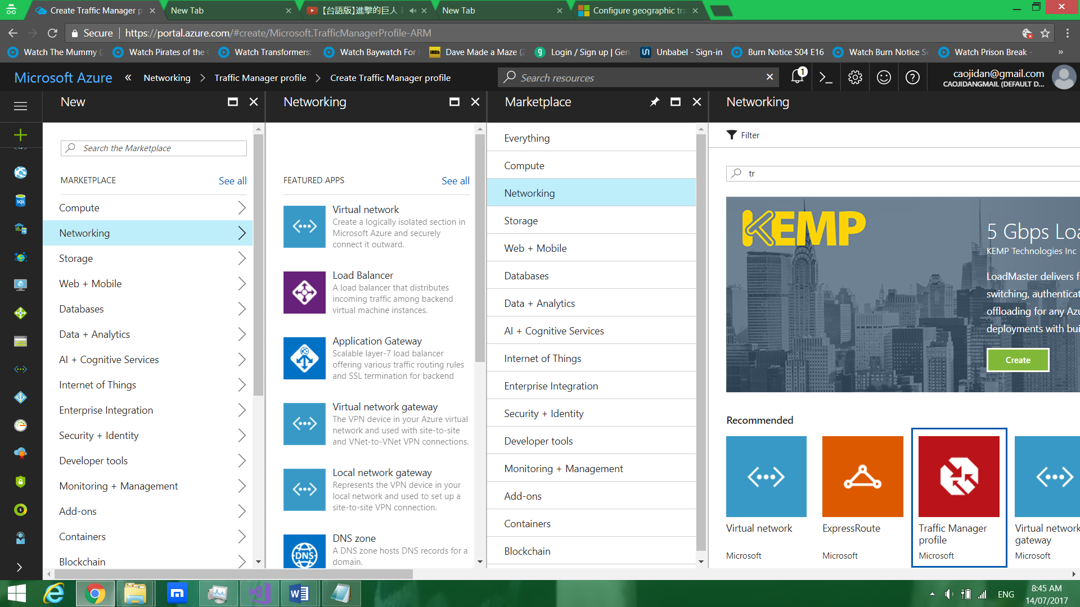

The diagram above shows for creating the Traffic Manager Profile.

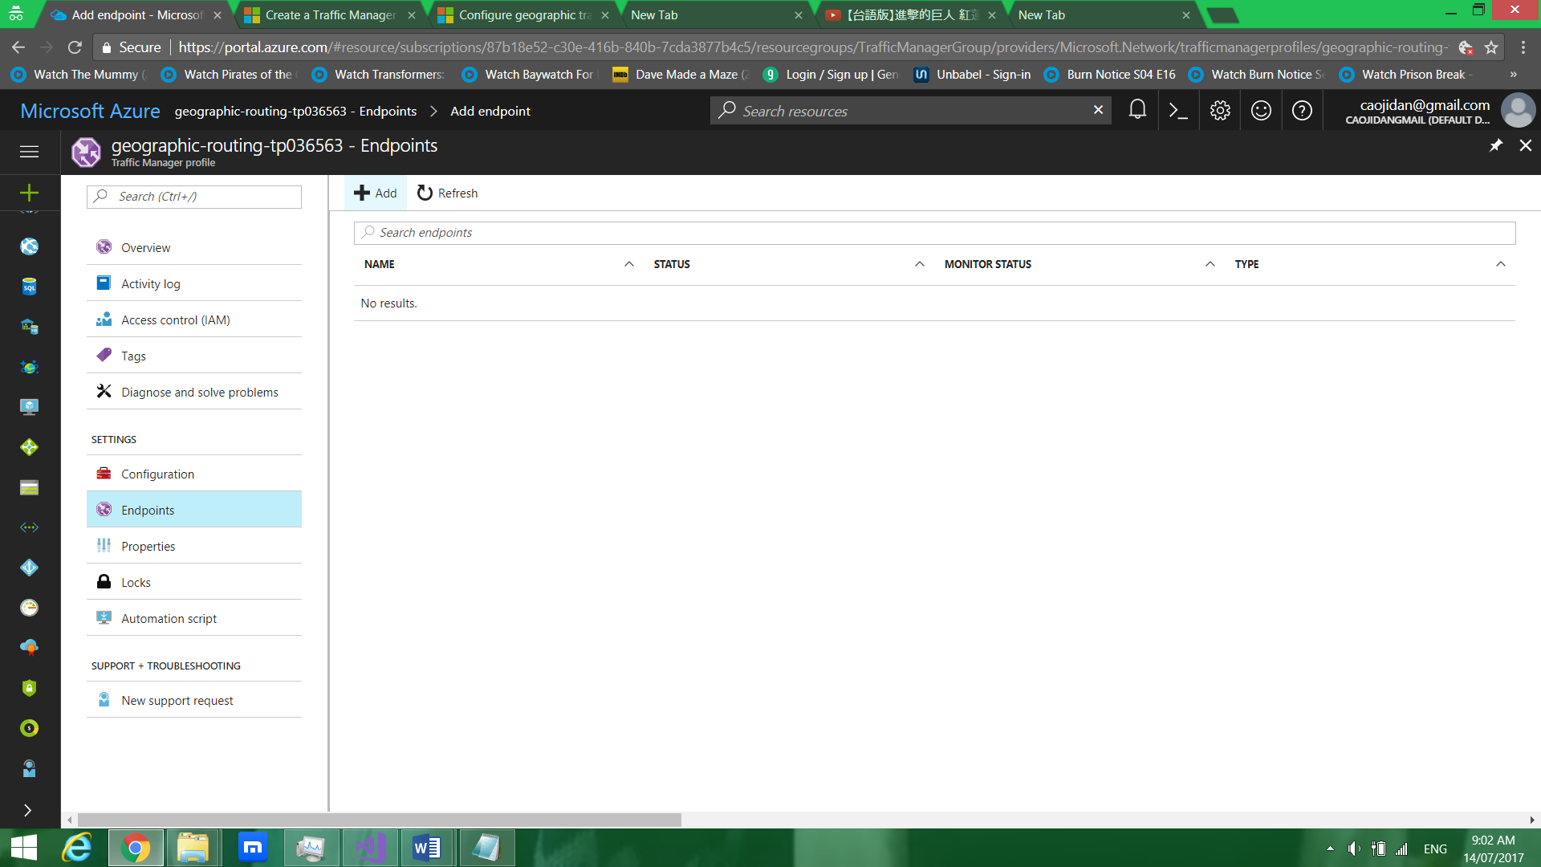

The diagram above shows for adding new endpoints.

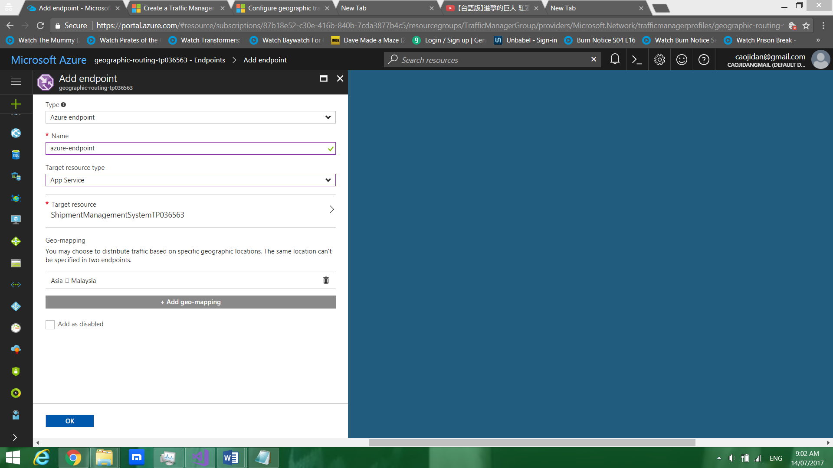

The diagram above shows for configuring new endpoints.

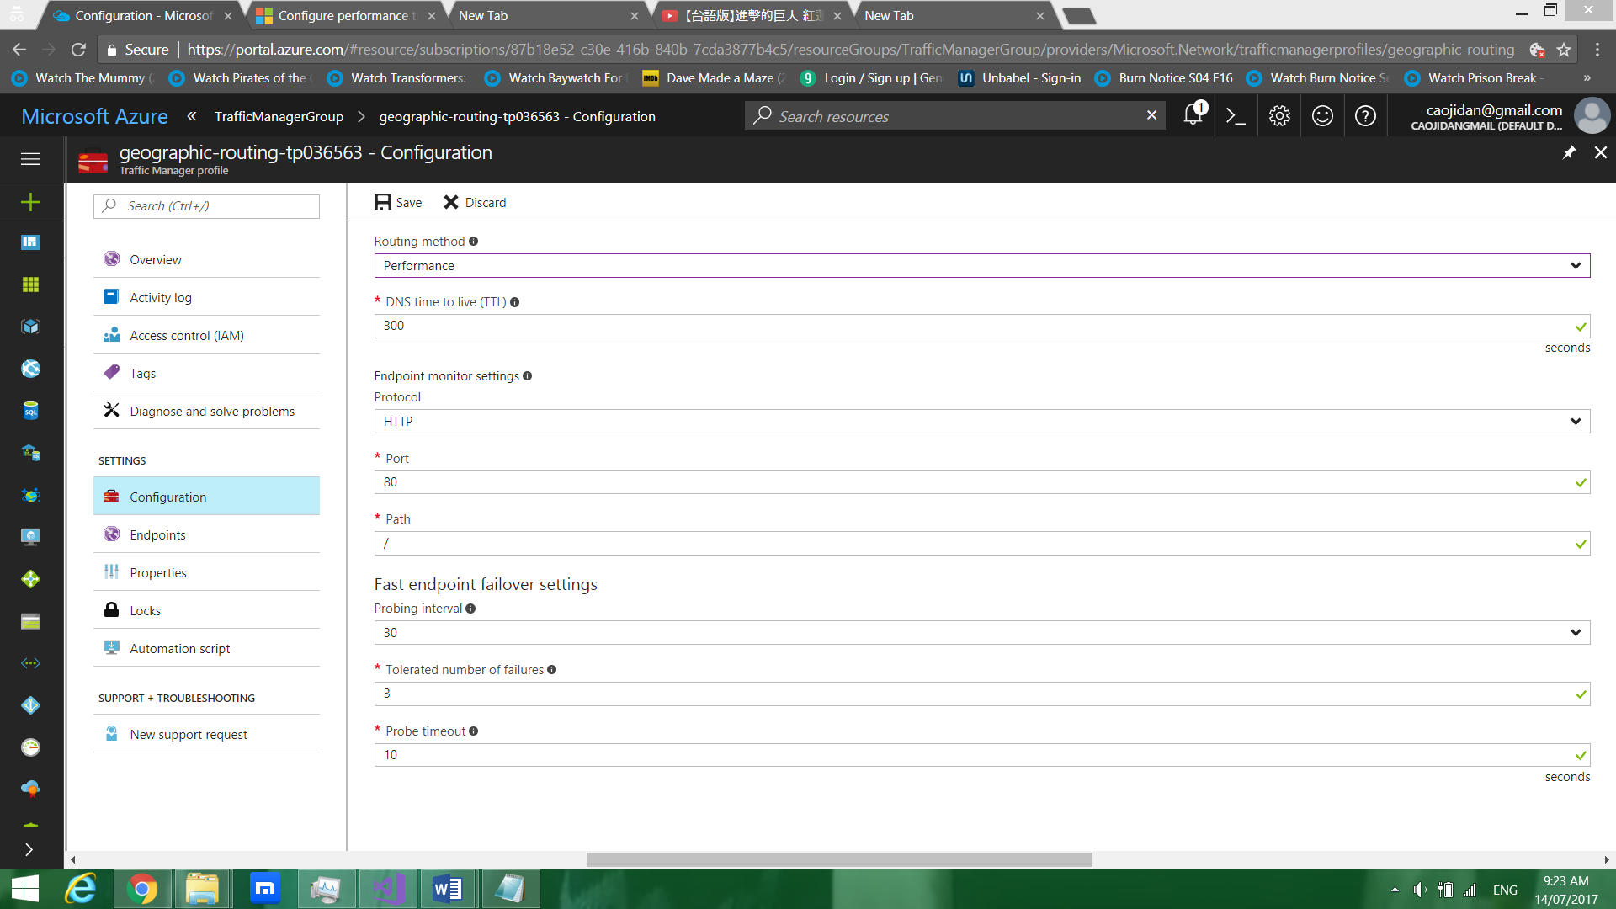

The diagram above shows for configuring the routing method to “performance” Traffic Manager Profile.

## 4.4.1 Diagnostics for enabling website logging

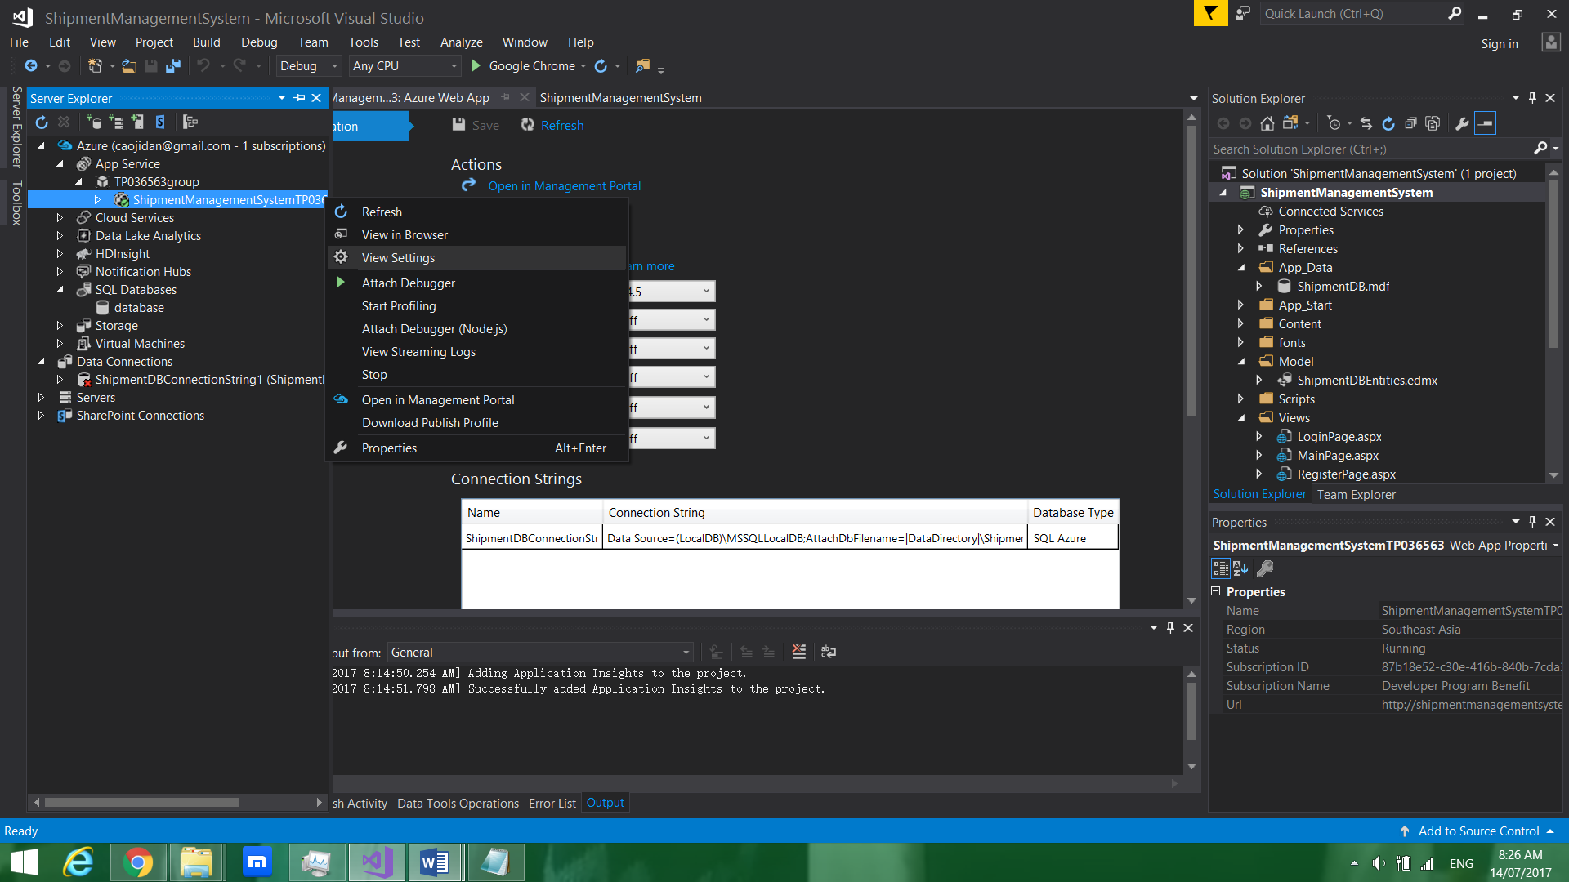

The diagram above shows for chooing for View Settings.

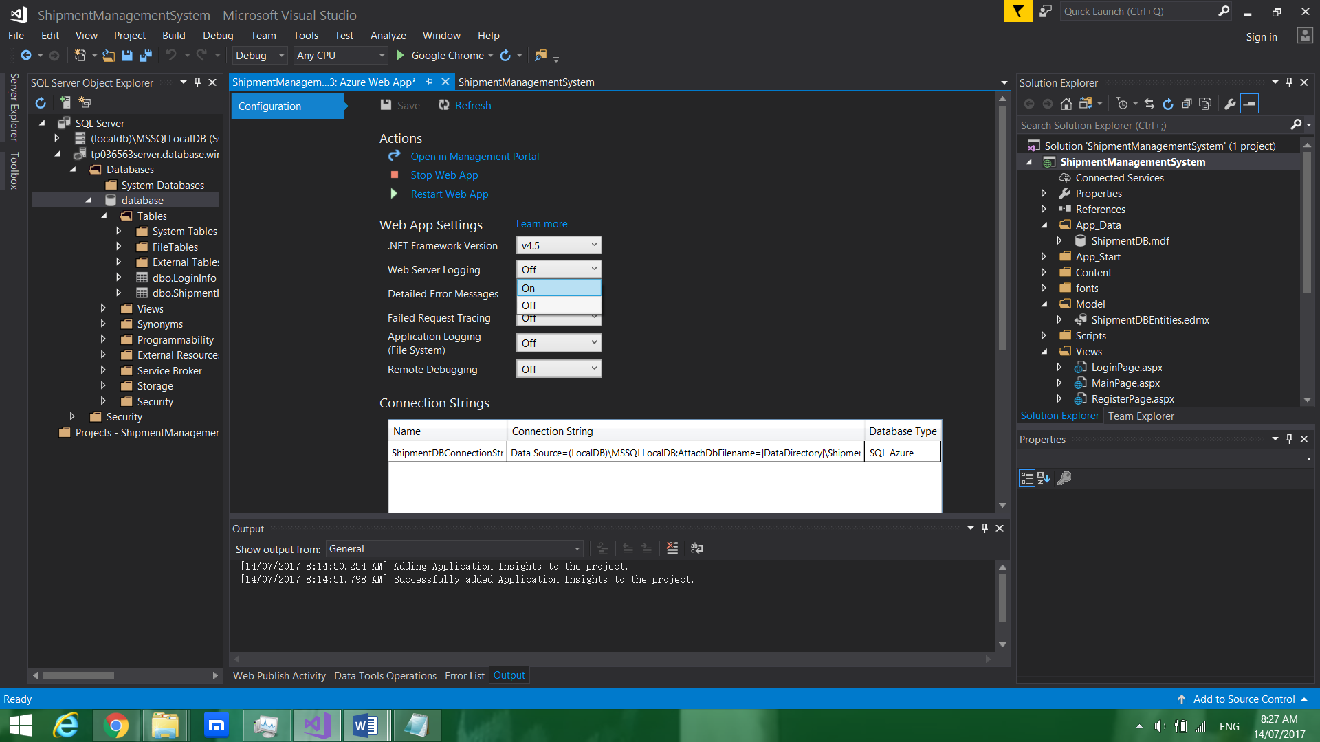

The diagram above shows for changing web server logging to on.

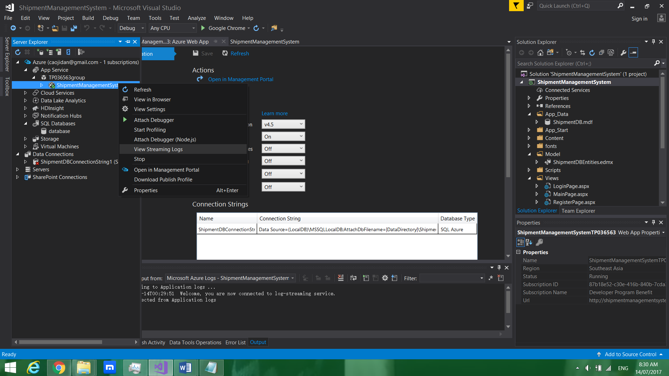

The diagram above shows for choosing View Streaming Logs.

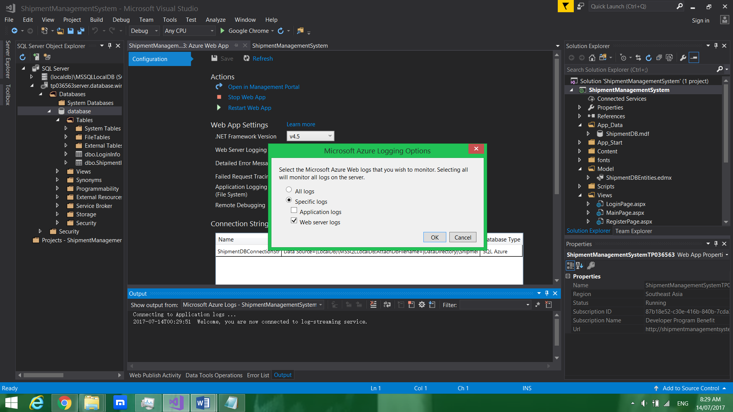

The diagram above shows for choosing web server log and uncheck application log.

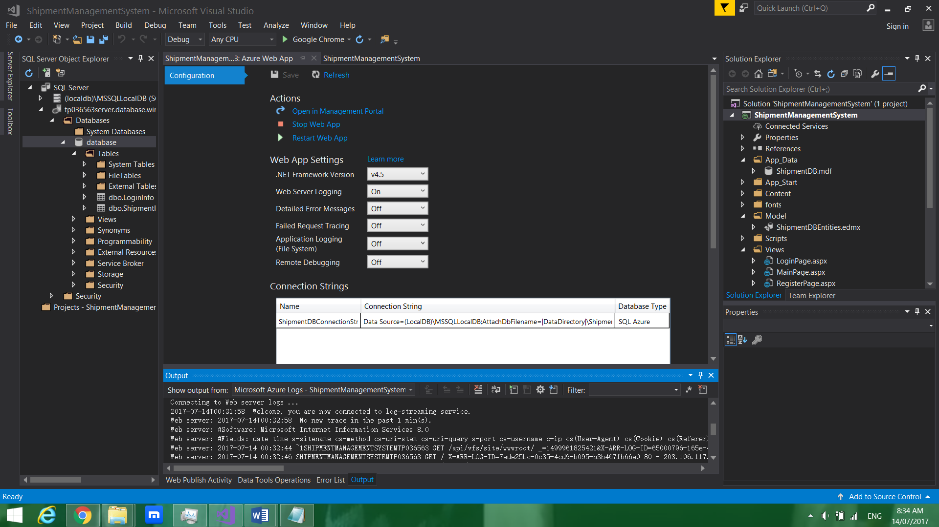

The diagram above shows the output of the web server log.

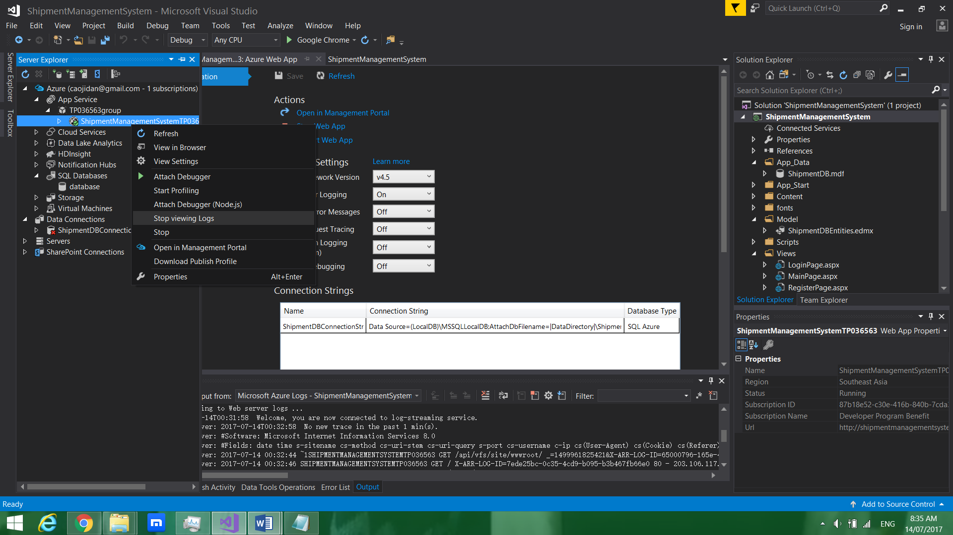

The diagram above shows for stopping the viewing logs.

## 4.5 Performance Testing

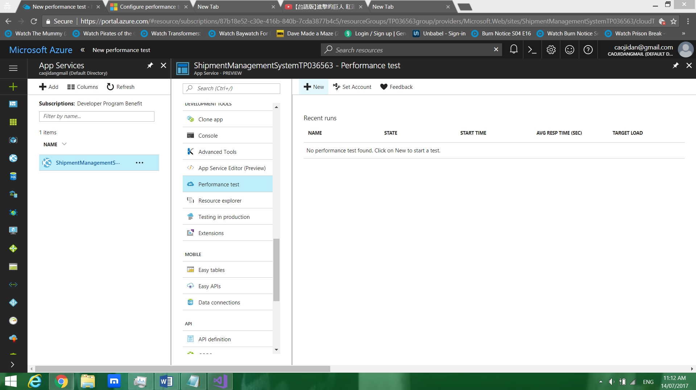

The diagram above shows creating new performance test.

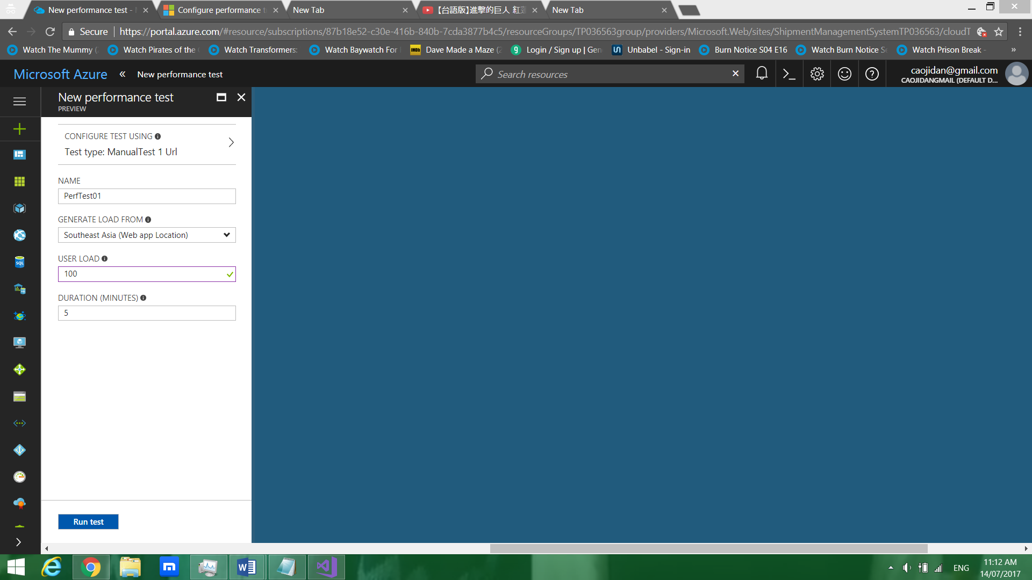

The diagram above shows configuring performance test 1.

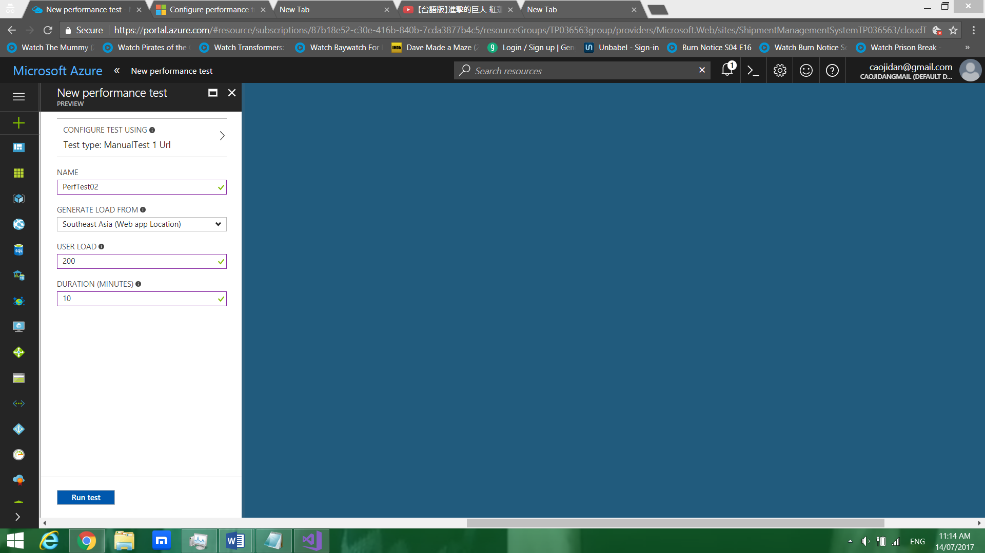

The diagram above shows configuring performance test 2.

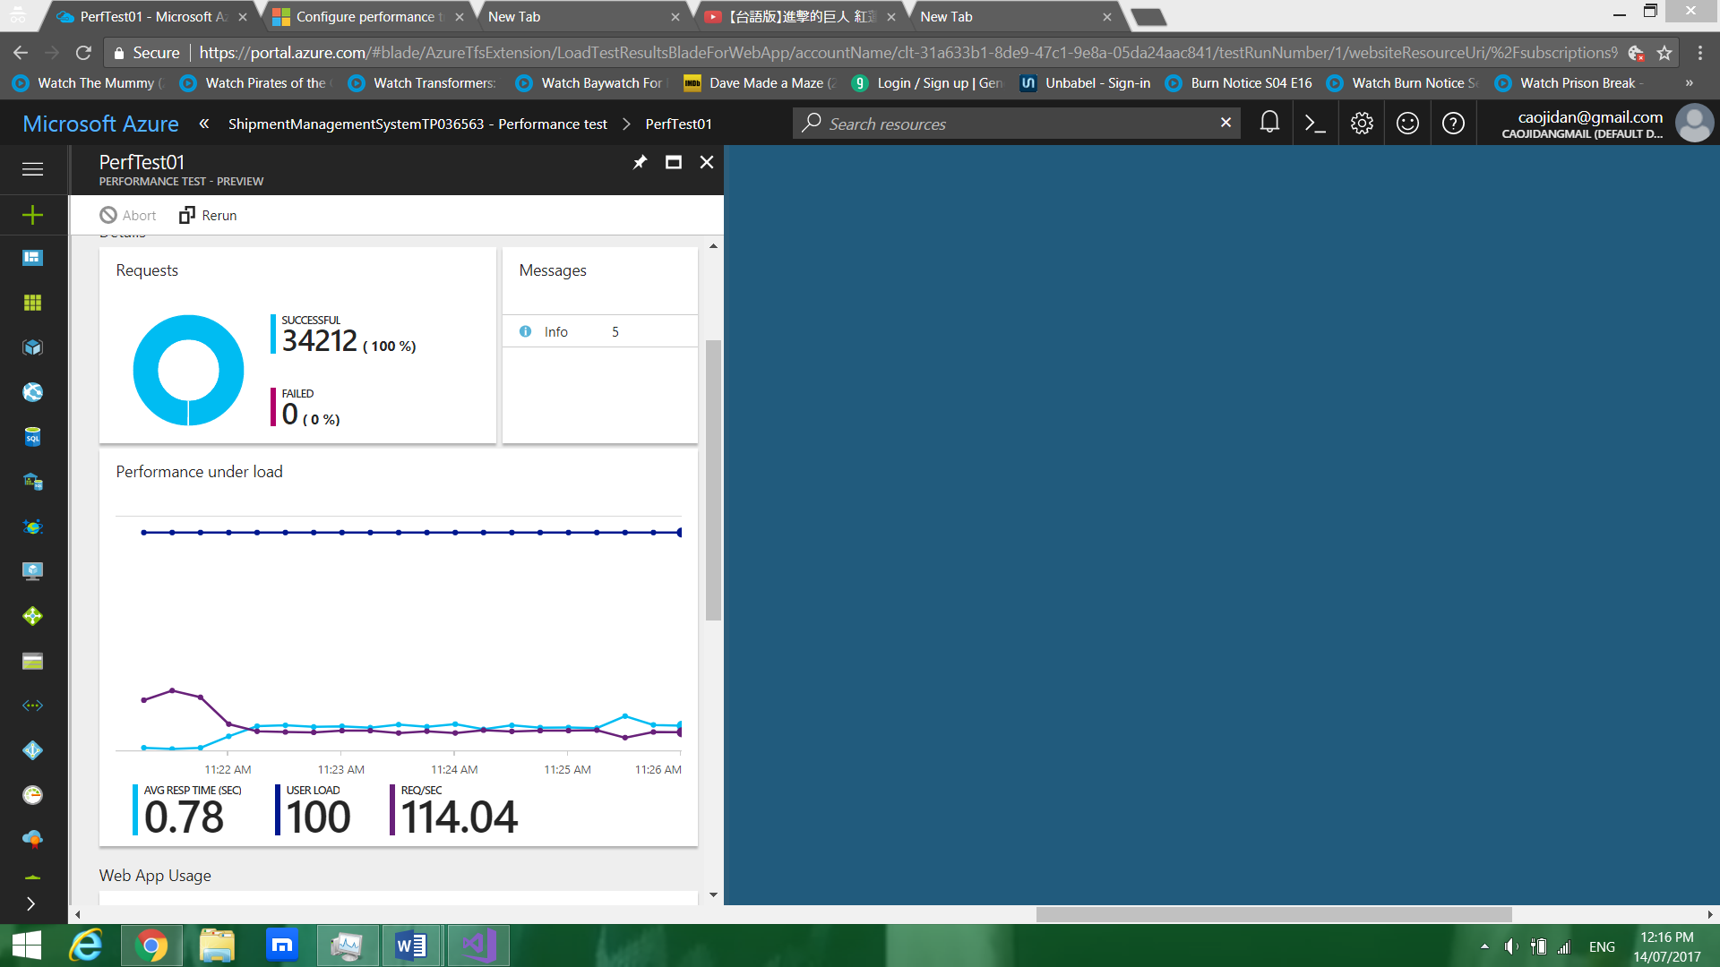

The diagram above shows the result of performance test 1.

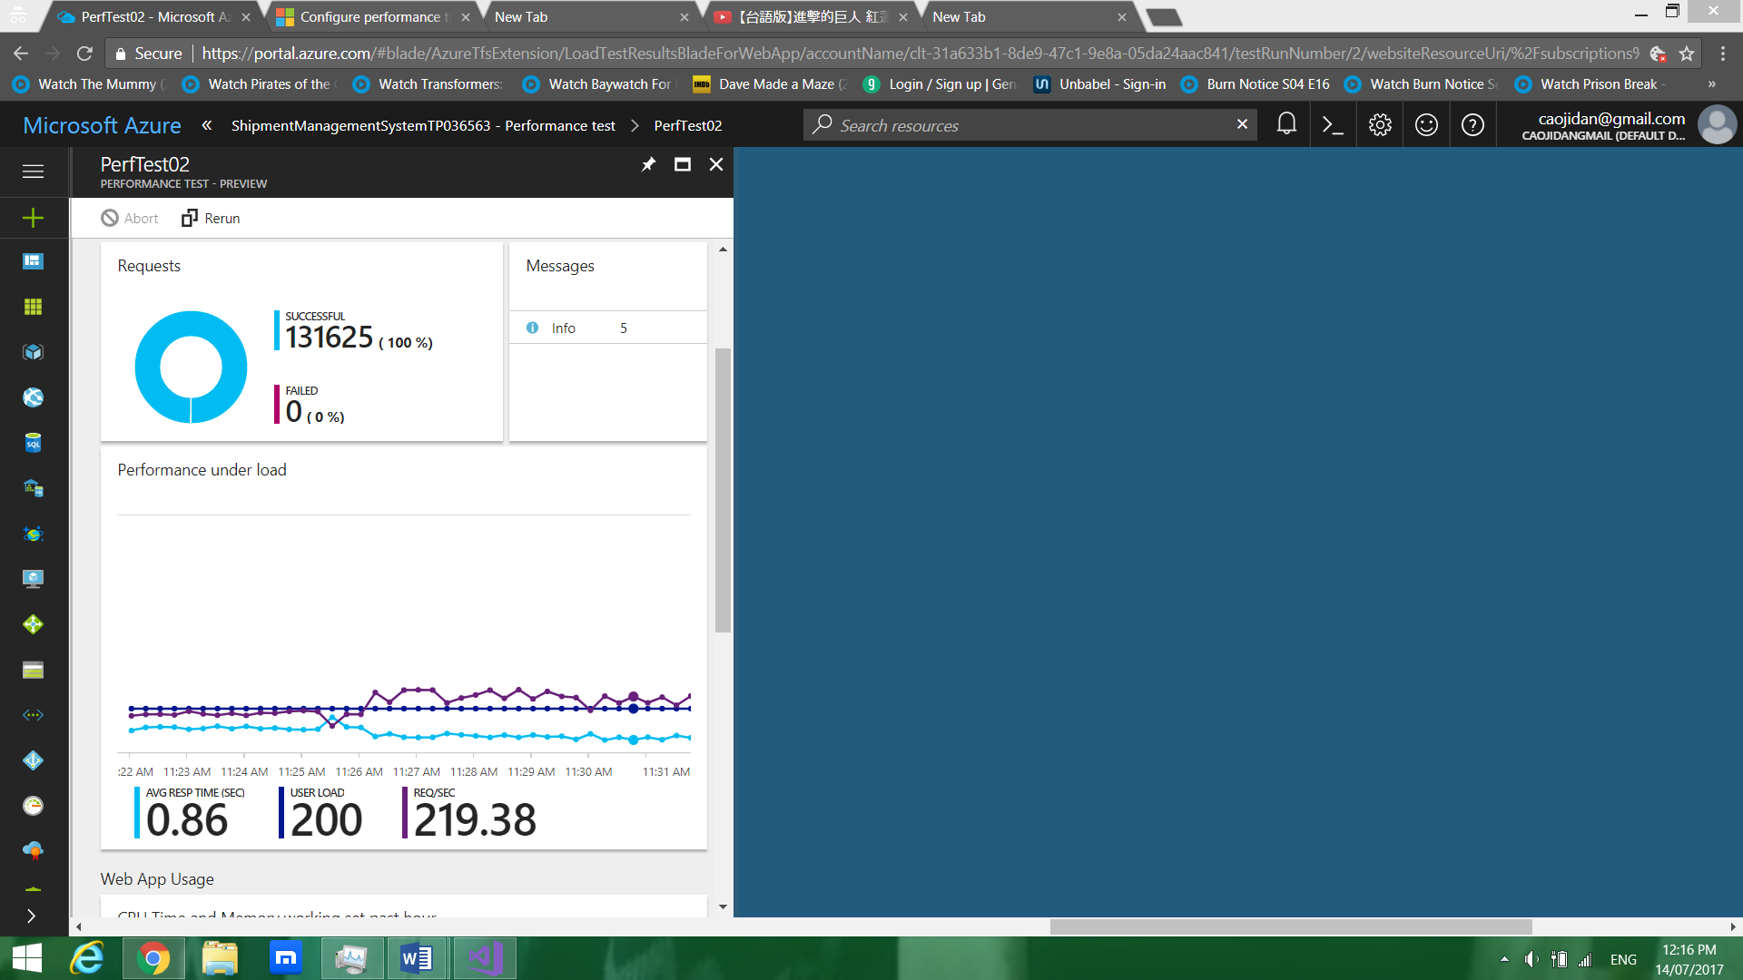

The diagram above shows the result of performance test 2.

### 4.5.1 Primary database performance

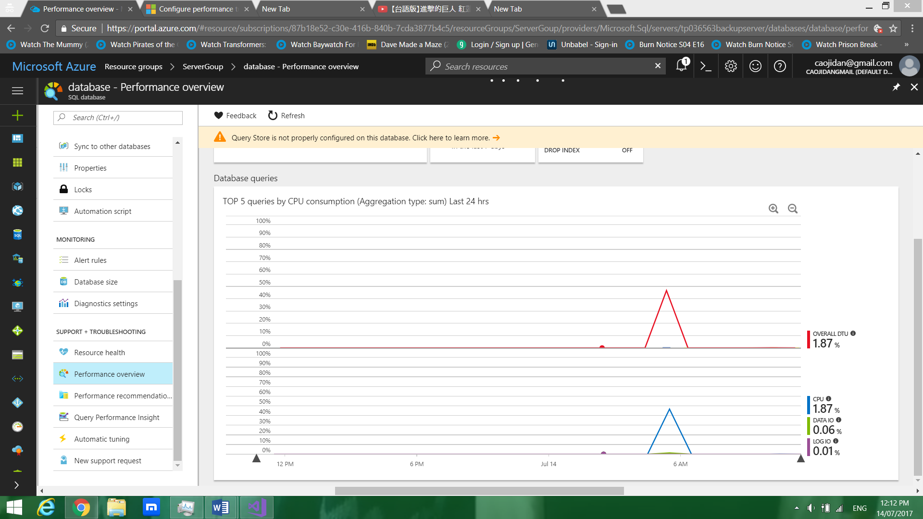

The diagram above shows the result of database performance.

# 5.0 Testing

## 5.1 Register Page

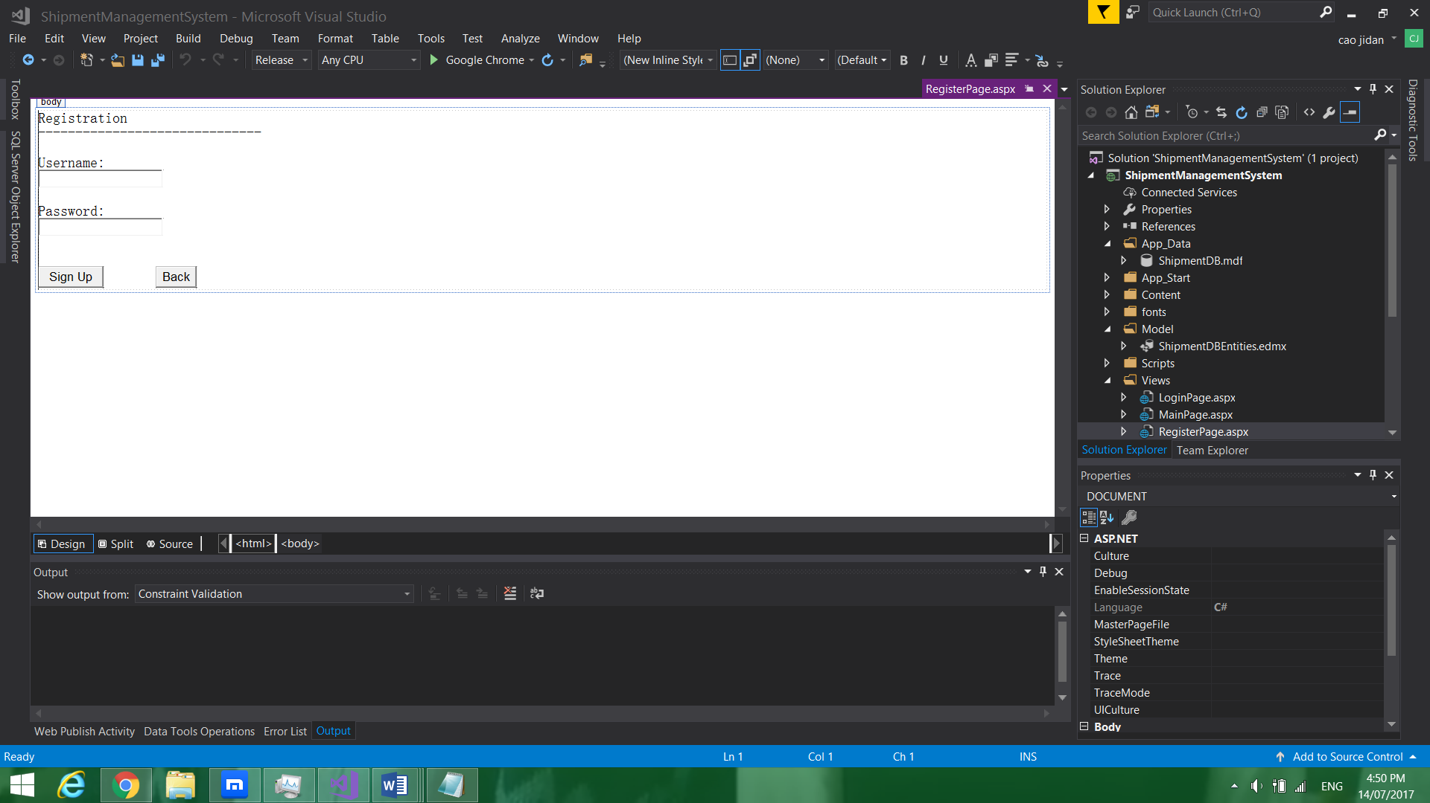

## 5.2 Login Page

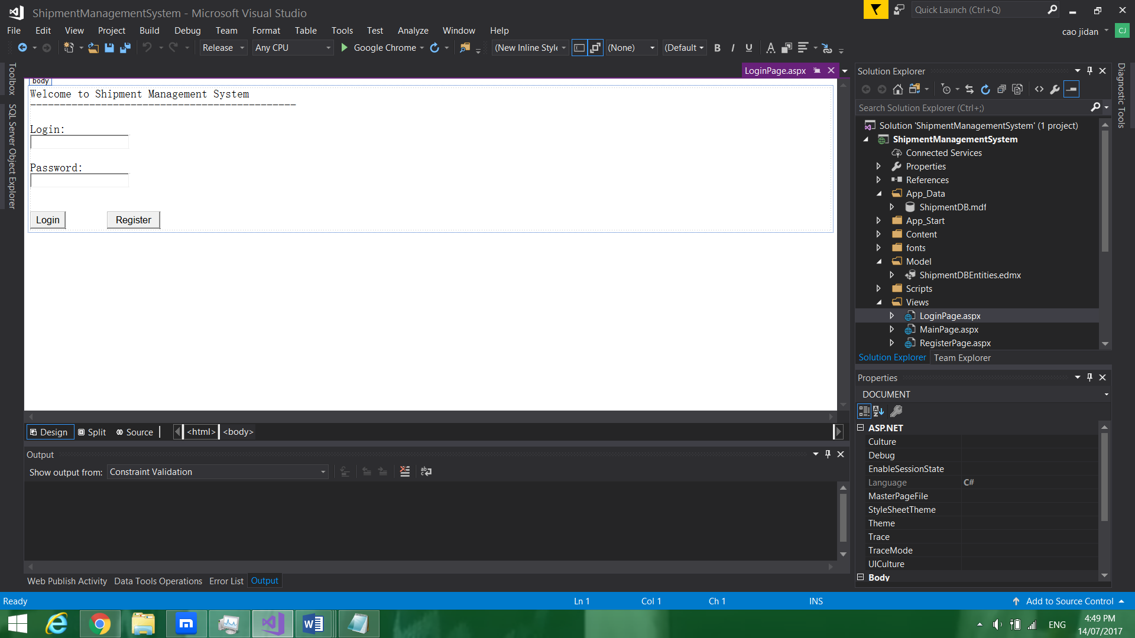

## 5.3 Main Page

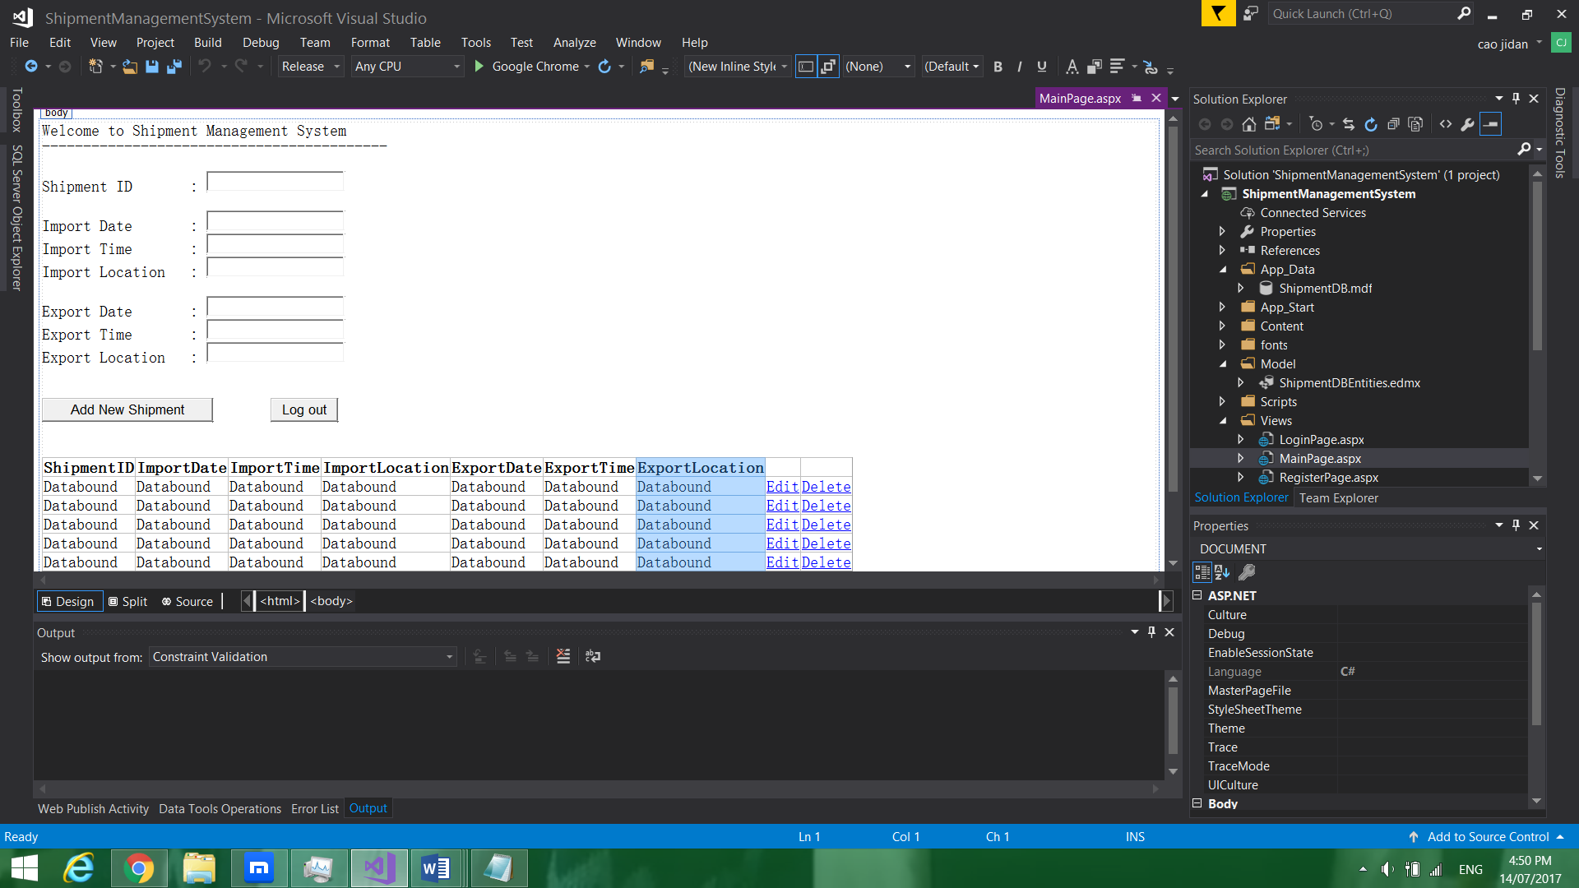

# 6.0 Critical Evaluation

The following provides a list of the most significant goals and requirements:

-Provisioning: You must be able to provision the new application to the Microsoft Azure Platform.

-Maintainability: You must be able to upgrade the application and perform other maintenance tasks while multiple tenants are using it.

-Monitoring: You must be able to monitor the application at all times to identify any problems and to troubleshoot them. This includes monitoring how each tenant is using the application.

-Availability: Tenants want the application to be constantly available, perhaps with guarantees defined in an SLA. Again, the activities of other tenants should not affect the availability of the application.

-Scalability: The application scales to meet the demand of the application.

# 7.0 Conclusion

After implementing the Azure services, the database of the system does not function anymore.

# 8.0 Personal Reflection

The developer learns a lot of knowledge since the system requires deep understanding in web application and Microsoft Azure.

# 9.0 Appendix

**GitHub Link:**

-URL: https://github.com/caojidan/DDAC_TP036563.git

**Web Application link:**

-URL: http://shipmentmanagementsystemtp036563.azurewebsites.net

**Database link:**

-URL: tp036563server.database.windows.net

**Backup Link:**

-URL: tp036563backupserver.database.windows.net

**Traffic Manager Link:**

-URL: http://geographic-routing-tp036563.trafficmanager.net

**Global Admin Account Information:**

-Domain Name: caojidangmail.onmicrosoft.com

-Username: ddacadmin@caojidangmail.onmicrosoft.com

-Password: Poga4958